Year 1 Plants

Enquiry questions: Can you name the parts of a plant? Can you name common plants? What is the different between evergreen and deciduous trees?

- Research and explain the parts of a flowering plant. You could draw a picture and label the parts of the plant.

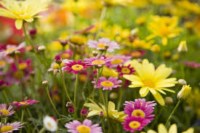
https://www.bbc.co.uk/bitesize/topics/zpxnyrd/articles/z3wpsbk

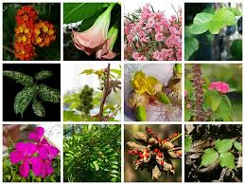
- Name some common plants and trees

After you have researched this try out one of these ideas:
- Write a description of the plant/tree
- Compare the plants/trees- What’s the same? What’s different?
- Create an ‘All about plants’ book to share what you have found out.

- Research different types of trees. Think about how they are the same/different

Create a poster too share information about different trees.

- Creative ideas linked to the Plant Topic:

Make a drawing/model of a flowering plant. You could use play-doh, pipe cleaners, paint
Plant some seeds. You could keep a diary!
Go for a walk in the local area- take photographs on the plants/trees that you see. You could create a pic-collage.

