Year 2 Plants

Enquiry questions: Can you name some common plans? Can you observe and describe how seeds and bulbs grow into plants? Can you find out what a plant needs to stay healthy?

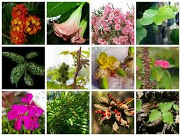
- Name some common plants and trees

After you have researched this try out one of these ideas:
- Write a description of the plant/tree
- Compare the plants/trees- What’s the same? What’s different?
- Create an ‘All about plants’ book to share what you have found out.

- Research what a plant needs to stay healthy.

Create a poster to share this information.

- Set up a mini investigation. If you can, plant some seeds and then change one things. This might be the amount of water, sunlight or what you plant the seed in. Maybe post photographs on the class forum/Facebook to help those who are unable to plant some seeds.

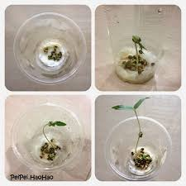
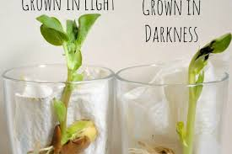

Creative ideas linked to the Plant Topic:

Make a drawing/model of a flowering plant. You could use play-doh, pipe cleaners, paint
Plant some seeds. You could keep a diary!
Go for a walk in the local area- take photographs on the plants/trees that you see. You could create a pic-collage.

