Year 1 Toys

Enquiry questions: What do you know about toys? How have toys changed overtime? How is your favourite toy different to your grown-ups/grandparents favourite toy when they were young?

- Have a look at your favourite toy. What material(s) is it made from? How does it work? Why is it your favourite toy? Do you think toys have always looked like this?
Draw a picture of your favourite toy and add labels to describe it.
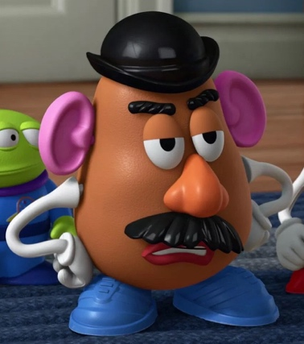

- Research toys old and new. See attached toys document. Compare the similarities and differences between the toys. How do they work? What material are they made from? How have they changed? Discuss how toys defined wealth in the past; poor children wouldn’t have had a dolls house for example. Draw a venn diagram. Label one circle old and the other new. Sort images of toys into the correct circle (or draw).

Old New

- Revisit your venn diagram. Add labels to describe how the toys have changed overtime. Think about the materials they are made from, what they look like and how they move. Compare the similarities and differences. Additional challenge: maybe you could think of another way to sort the toys?

- Now, get your teddy bear or think about our class bear in our reading corner. With your bear, listen to the story ‘Old Bear by Jane Hissey’. Discuss how old bear is different from your teddy bear. Look at images of bears using the attached PPT. Which bear do you think is the oldest/newest on slide one? Why? Think of adjectives to describe the different types of bears.
https://www.youtube.com/watch?v=ePCof76DLO0
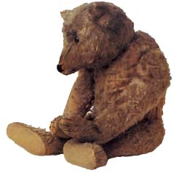

- Do you think your grown-ups/grandparents would have played with a nintendo switch or a large, fluffy teddy bear whenever they were young? Talk to your grown-ups/grandparents about their favourite toy. Ask them some questions to find out what material is was made from and why it was their favourite.

Creative Links to Toys Topic:
- Make paint prints using different toys.
- Make a drawing/model of a toy. You could use playdough, cardboard boxes or wood.
- Spend the day with your toy.
- Puppets are toys which have always been played with. You could make your own puppet.
- Write instructions on how to make a puppet.
- Write a letter to your grown-ups or grandparents to thank them for sharing stories about toys they played with whenever they were young.

