Year 2 History - Our local area

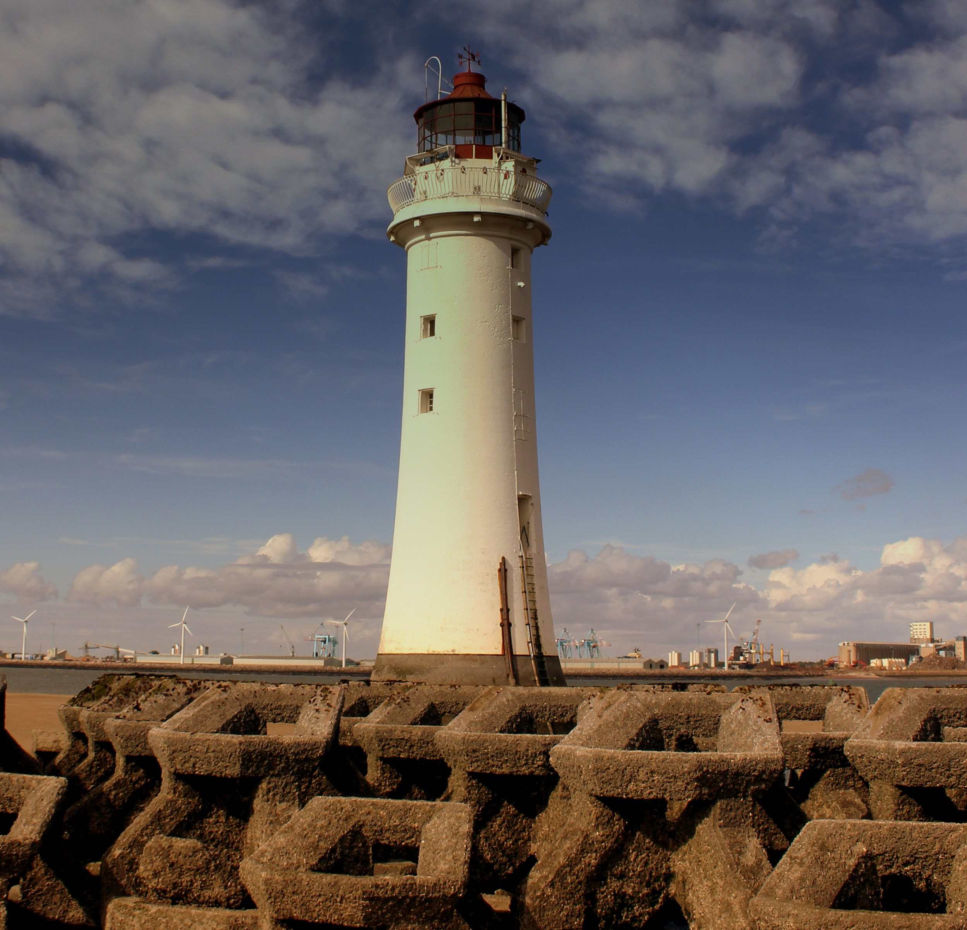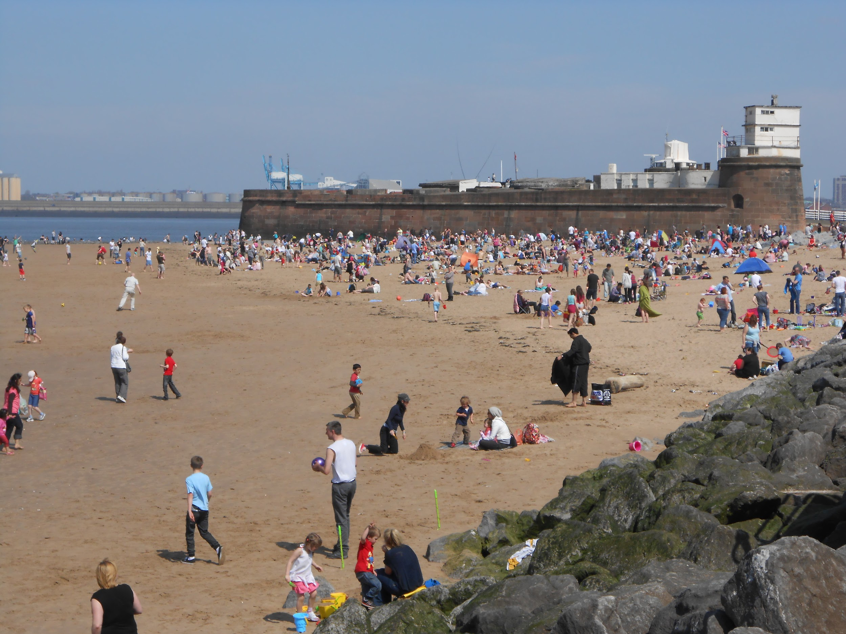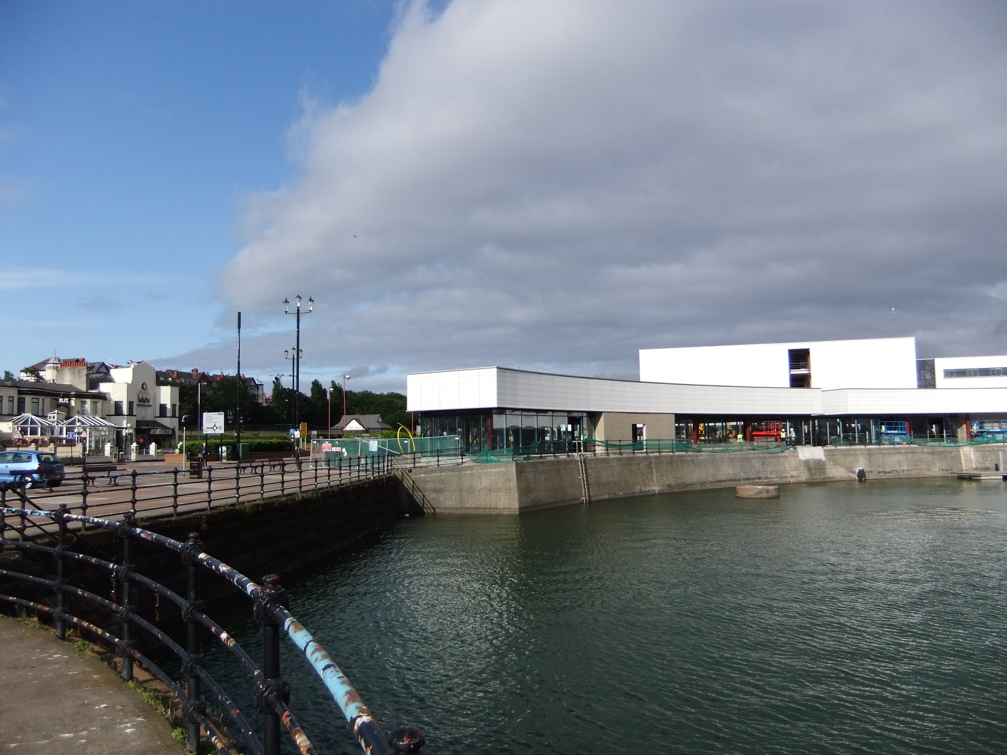
Enquiry questions: Can you show what you already know about our local area and its history? Can you research how ships have been an important part of our local history? Can you go back in time and write about what you see?

- Create a poster about what you already know about the history of our local area.

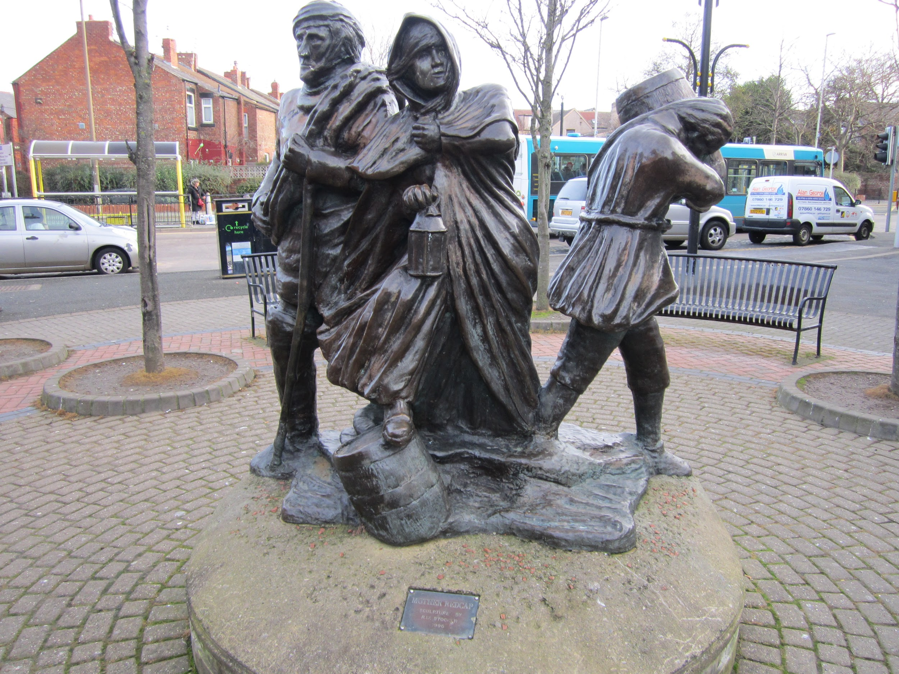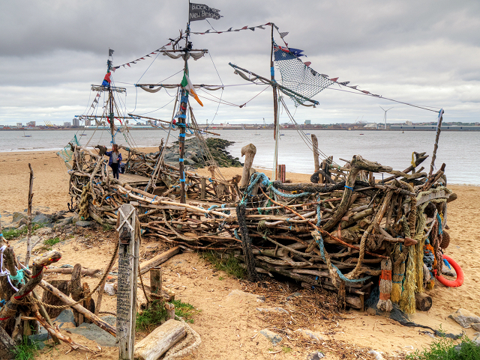

- Research how ships/boats have played a significant part in our local history.

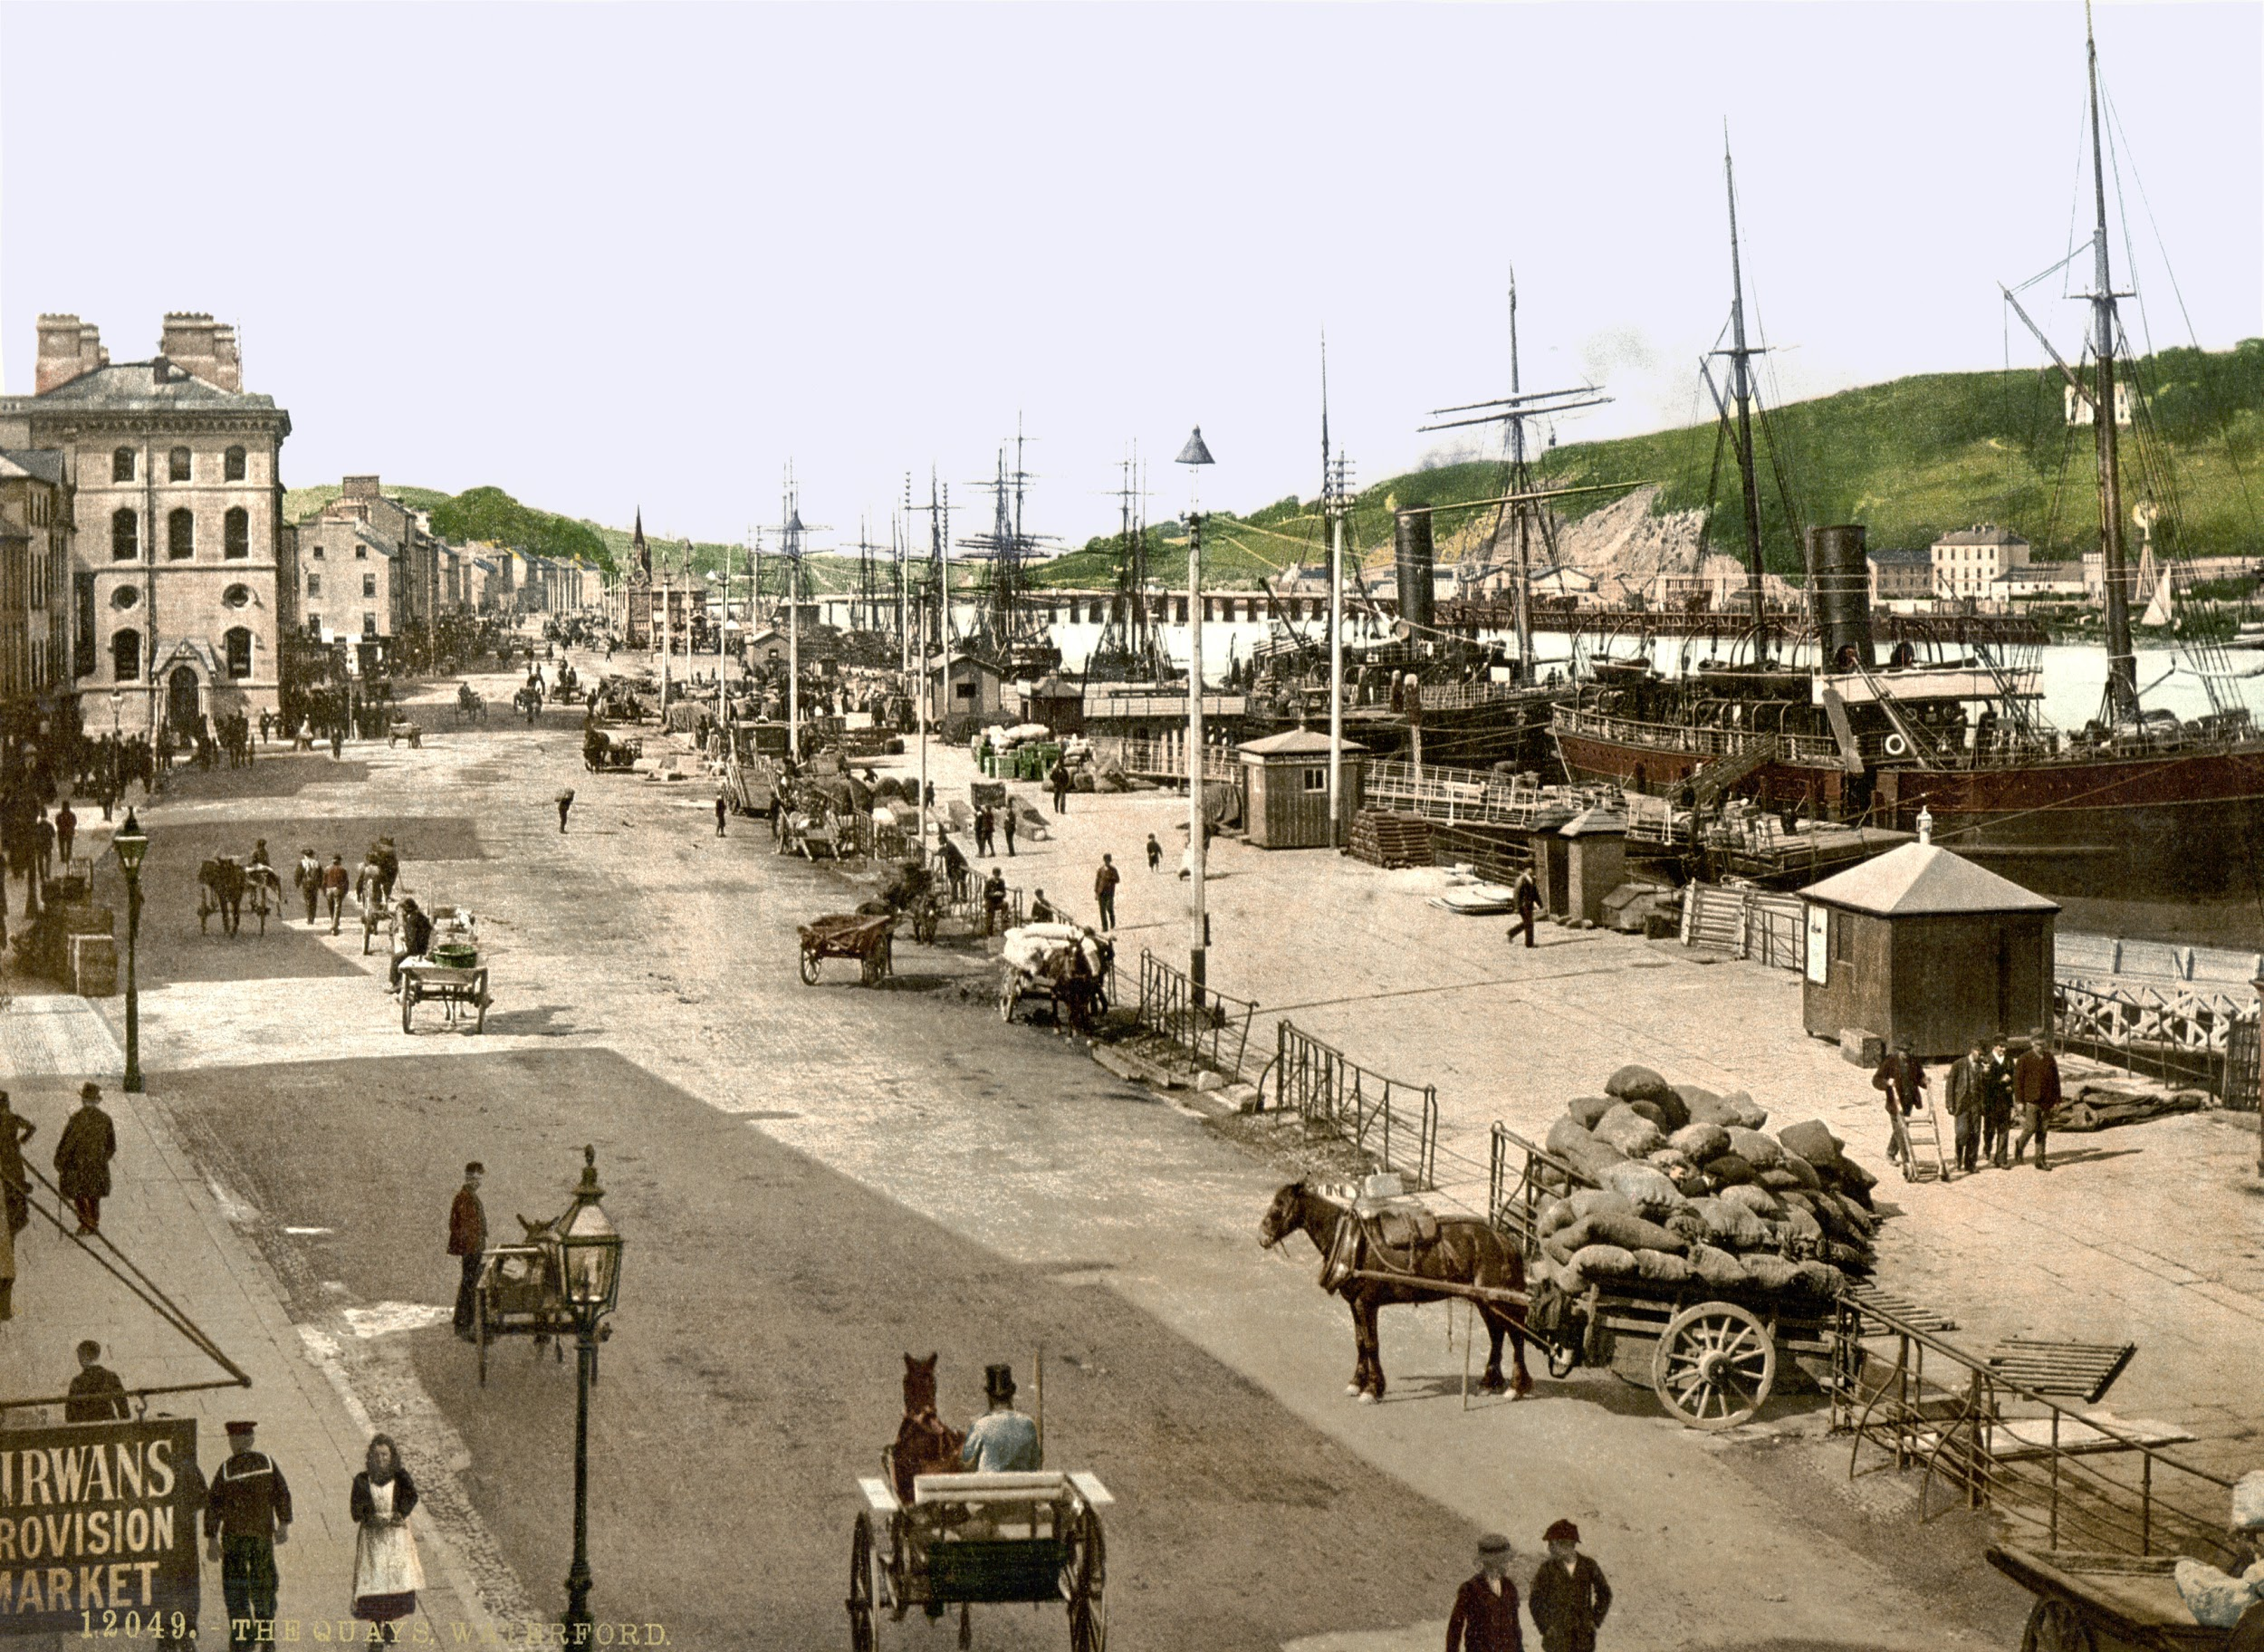 Can you now create a mind map to show your research?

- Imagine you are a time traveller and have gone back in time. Write a description of what you see.

Creative links:
Draw or paint the skyline. Use lego to create a map of our local area - take a photo if you can.

