Claes Oldenburg Sculpture Project
Year 5 and 6

If you would like to present your work in a sketchbook, there is a tutorial here with some lovely ideas for how you could do this at home. We would love to see some pictures on our Facebook page

- Claes Oldenburg- background
Claes Oldenburg (born January 28, 1929) is an American sculptor, best known for his public art installations typically featuring large replicas of everyday objects. Another theme in his work is soft sculpture versions of everyday objects. Many of his works were made in collaboration with his wife, Coosje van Bruggen, who died in 2009; they had been married for 32 years. Oldenburg lives and works in New York.

Explore the map below to find out where Mesopotamia was.
https://www.dkfindout.com/us/history/mesopotamia/where-was-mesopotamia/
Task – Can you write a message in the cuneiform alphabet and ask someone in your house to translate it? See resources.

- Where is Baghdad and why was it important?
Locate Baghdad on the map in the link below. Can you recognise any other countries nearby? Why do you think Baghdad was such an important place for traders?
https://www.ducksters.com/geography/middleeast.php
Watch the clip below and complete the task
https://www.bbc.co.uk/teach/class-clips-video/baghdad-in-900ad-the-golden-age-of-islam/zjfxpg8
Task – Write a letter from one scholar in Baghdad to another elsewhere in the world explaining why Baghdad is such an exciting city to study in.

- Why was the city round and what was inside?
Baghdad was built in a circular shape. At the centre of this round city was the Mosque and a palace, in the surrounding areas were government buildings and accommodation for guards. Outside the city walls were markets and homes. Four avenues of trees spanned out from the centre of the city stretching to each of the four city gates. This enabled people to access the city from whichever direction they were travelling in. Watch the link which shows the city created in minecraft!
https://www.youtube.com/watch?v=jgsEY9ZabKM&safe=true
Task (choose one or more of the following) –
- Draw/paint/model and label a representation of the original layout of Baghdad.
- Write a description of the original layout of Baghdad from the point of view of a builder working on the construction of the city.
- Write a description of Baghdad from the point of view of a trader coming into the city. Look at the size of the Abbasid Empire and discuss what produce you may have been able to buy in a market in Baghdad.

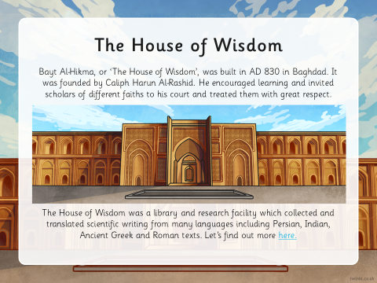
- What was the house of Wisdom and why was it important?
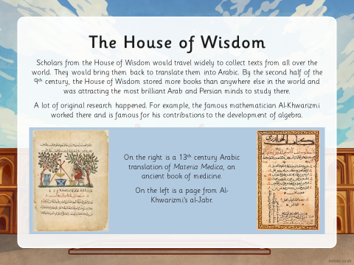

Task- Using the information above and through your own research, create a poster advertising scholars to come to the ‘House of Wisdom’.

