Claes Oldenburg Project
Year 5 and 6
If you would like to present your work in a sketchbook, there is a tutorial here with some lovely ideas for how you could do this at home. https://www.accessart.org.uk/sketchbooks-an-online-course-for-children-families-parents-teachers/
We would love to see some pictures on our Facebook page.

- Claes Oldenburg- background
Claes Oldenburg (born January 28, 1929) is an American sculptor, best known for his public art installations typically featuring large replicas of everyday objects. Another theme in his work is soft sculpture versions of everyday objects. Many of his works were made in collaboration with his wife, Coosje van Bruggen, who died in 2009; they had been married for 32 years. Oldenburg lives and works in New York.
Here are some examples of his sculptures:
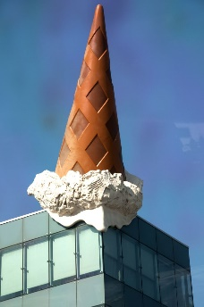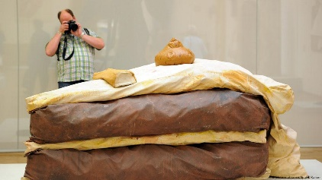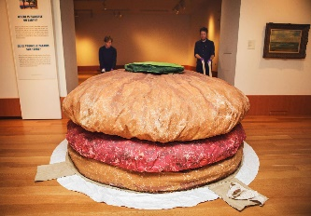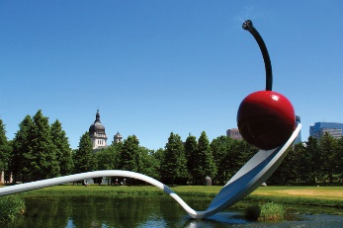
You can find out more here:
http://www.oldenburgvanbruggen.com/
Task – Find out a bit more about Claes Oldenburg and his work. Which are your favourite pieces? How would you describe his style? Why do you think he created these sculptures?

- Recreate some of Claes Oldenburg’s ideas through drawings.
This is where you could begin to work as you would in a sketchbook. You could use pieces of paper, an old scrapbook or over make your own sketchbook following the tutorial at the top of the page. Here are some sketchbook examples to help you get started:
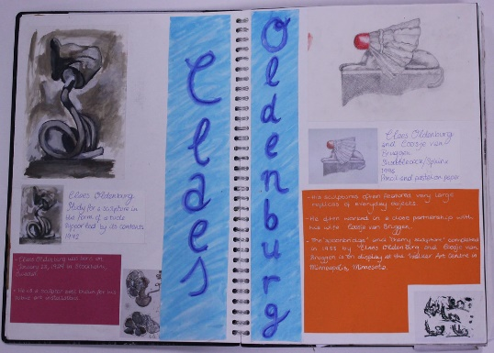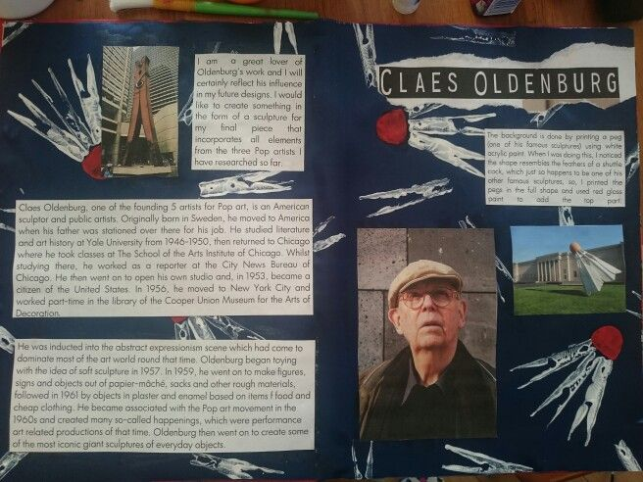
Task – Record what you have found out about Claes Oldenburg and have a go at drawing some of his work in your own style.

- What can you find in your surroundings to be inspired by?
Think about the work Claes Oldenburg has created. He takes everyday objects and makes them unusual and interesting. What can you find in your house to do this with? Start by finding objects with interesting shapes/ forms and sketch them. Try looking at them from different angles. You might want to make an arrangement of objects. You could photograph them and draw from the photographs. Record all of this in your sketchbook if you have one.
Task- to sketch objects from around the house
4. Create your own Claes Oldenburg inspired piece of artwork
Look back at the work you have done so far. How will you create your final piece of artwork inspired by Claes Oldenburg? You can of course make more than one if you choose to.

Could you:
make a sculpture out of objects from around the house?
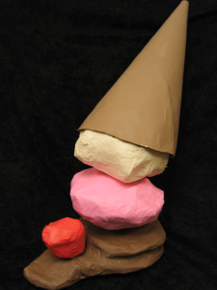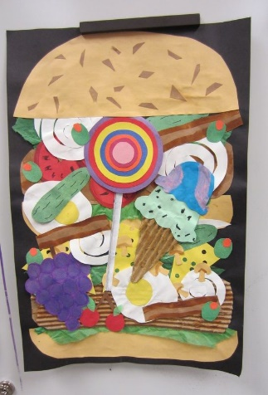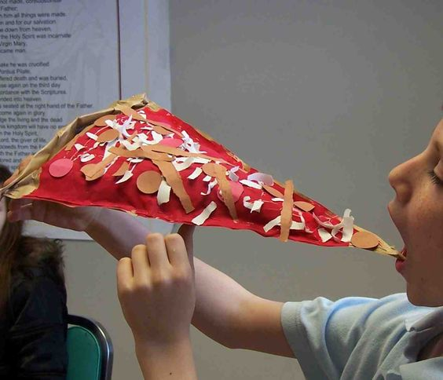
Use drawing or painting to turn everyday objects in to something else?
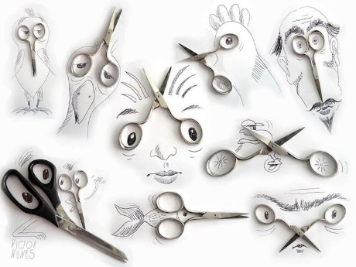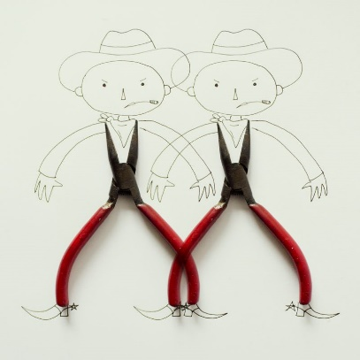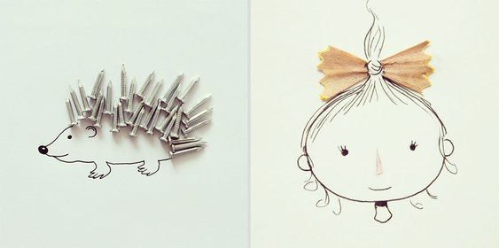

Task- Using your research and sketches, create your own piece of artwork

If you enjoyed this, why not find out more about artists who use everyday objects in their work?

