Roman Empire and its impact on Britain

Enquiry questions: Why did the Romans invade? Why did the British resist?
How did lives change because of the Roman invasion?

- Research and explain the reasons why the Romans invaded Britain.
Can you complete these sentences?
The Romans invaded because…
Their invasion was successful because…
The British resisted because….
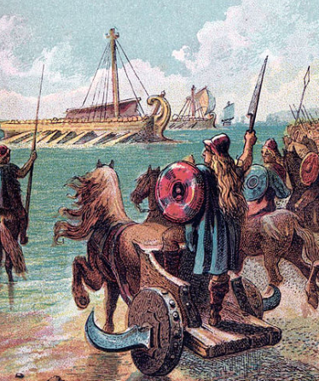
https://www.bbc.co.uk/bitesize/topics/zqtf34j/articles/z9j4kqt

- Find out about Boudicca and the reasons for her uprising

After you have researched this try out one of these ideas:
- Write a speech in role as Boudicca to persuade people to join the fight.
- Write a diary entry as Boudicca.
- Create a fact file about her.
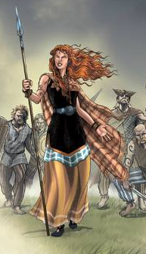

- Research and find out about the Roman legacy.
Make a folding book or a short presentation about the Roman legacy.
https://www.bbc.co.uk/teach/school-radio/history-ks2-romans-legacy-1/zjmyscw
https://www.ducksters.com/history/ancient_rome/legacy_of_rome.php

- Creative ideas linked to the Roman Topic:

Make a Roman building, shield or helmet out of recyclable materials.
Make a Roman mosaic.
Make your own bread (staple food of Ancient Rome).
