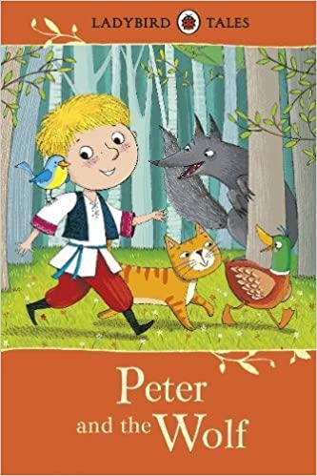
Music Home Learning Key Stage One

Peter and the Wolf -(Sergei Prokofiev)

Peter lives at his Grandfather’s home in a clearing in the forest. One fine day, Peter goes out into the clearing, leaving the gate open: a duck that lives in the yard takes a dip in the pond nearby. The duck starts an argument with a little bird whilst Peter’s cat eyes both up as a potential snack. Peter warns the bird about the stalking cat and the bird flies up into a tree: the duck swims to the middle of the pond. Grandfather scolds Peter for being outside when there could be a wolf around but Peter takes no notice. So, his Grandfather takes him inside and locks the gate. Soon after, a wolf makes his presence felt; appearing menacingly from the dark forest. The cat deftly climbs a tree but the poor duck, which jumps out of the pond and attempts to run for cover, is swallowed in one gulp by the wolf. Peter fetches a rope and climbs the garden wall and into a tree. He has a cunning plan!! He gets the little bird to fly around and distract the wolf whilst he lowers a noose to capture the wolf by its tail. Peter succeeds to trap the wolf and when some hunters appear, ready to kill the wolf, Peter persuades them to take the wolf to a zoo in a victory parade that includes all the characters (even the duck that is inside the Wolf’s tummy!!)
https://www.youtube.com/watch?v=BElkXlj9Qv8
Can you recognise and name any of the instruments you can hear?
Can you find out about the instrument you hear and find out which section of the orchestra they belong to?
Which instrument represents each character from the story?
Is the music fast or slow?
Is the music loud or quiet?
Can you draw a story map as you listen to the music?
Can you research facts about the composer Sergei Prokofiev?

