Key Stage 1 – Art

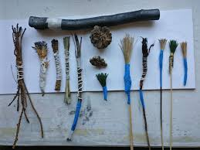
- Mark marks in print with a variety of object including natural and man-made
Can you create marks using natural objects outside? Can you write your name?

- Collect some leave.
Make rubbings using crayons or other mark making materials.
Can you make a pattern?

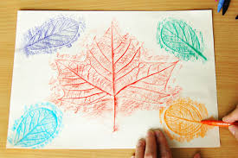

- Build a repeating pattern and recognise pattern in the environment.
You could use the pic collage app to create your pattern.

