RE-Judaism
Enquiry: What is holiness for Jewish people: a place, a time, an object or something else?
- Investigate the word, ‘holy’.
Look up the word in a dictionary. Find synonyms (words with a similar meaning) using a thesaurus.
Can you complete this sentence?
I think that holy means……………………………..

- Watch this BBC video about a Torah Scroll:
https://www.bbc.co.uk/teach/class-clips-video/what-is-the-torah/zhs2t39
Draw an outline of a scroll and answer this question inside it:
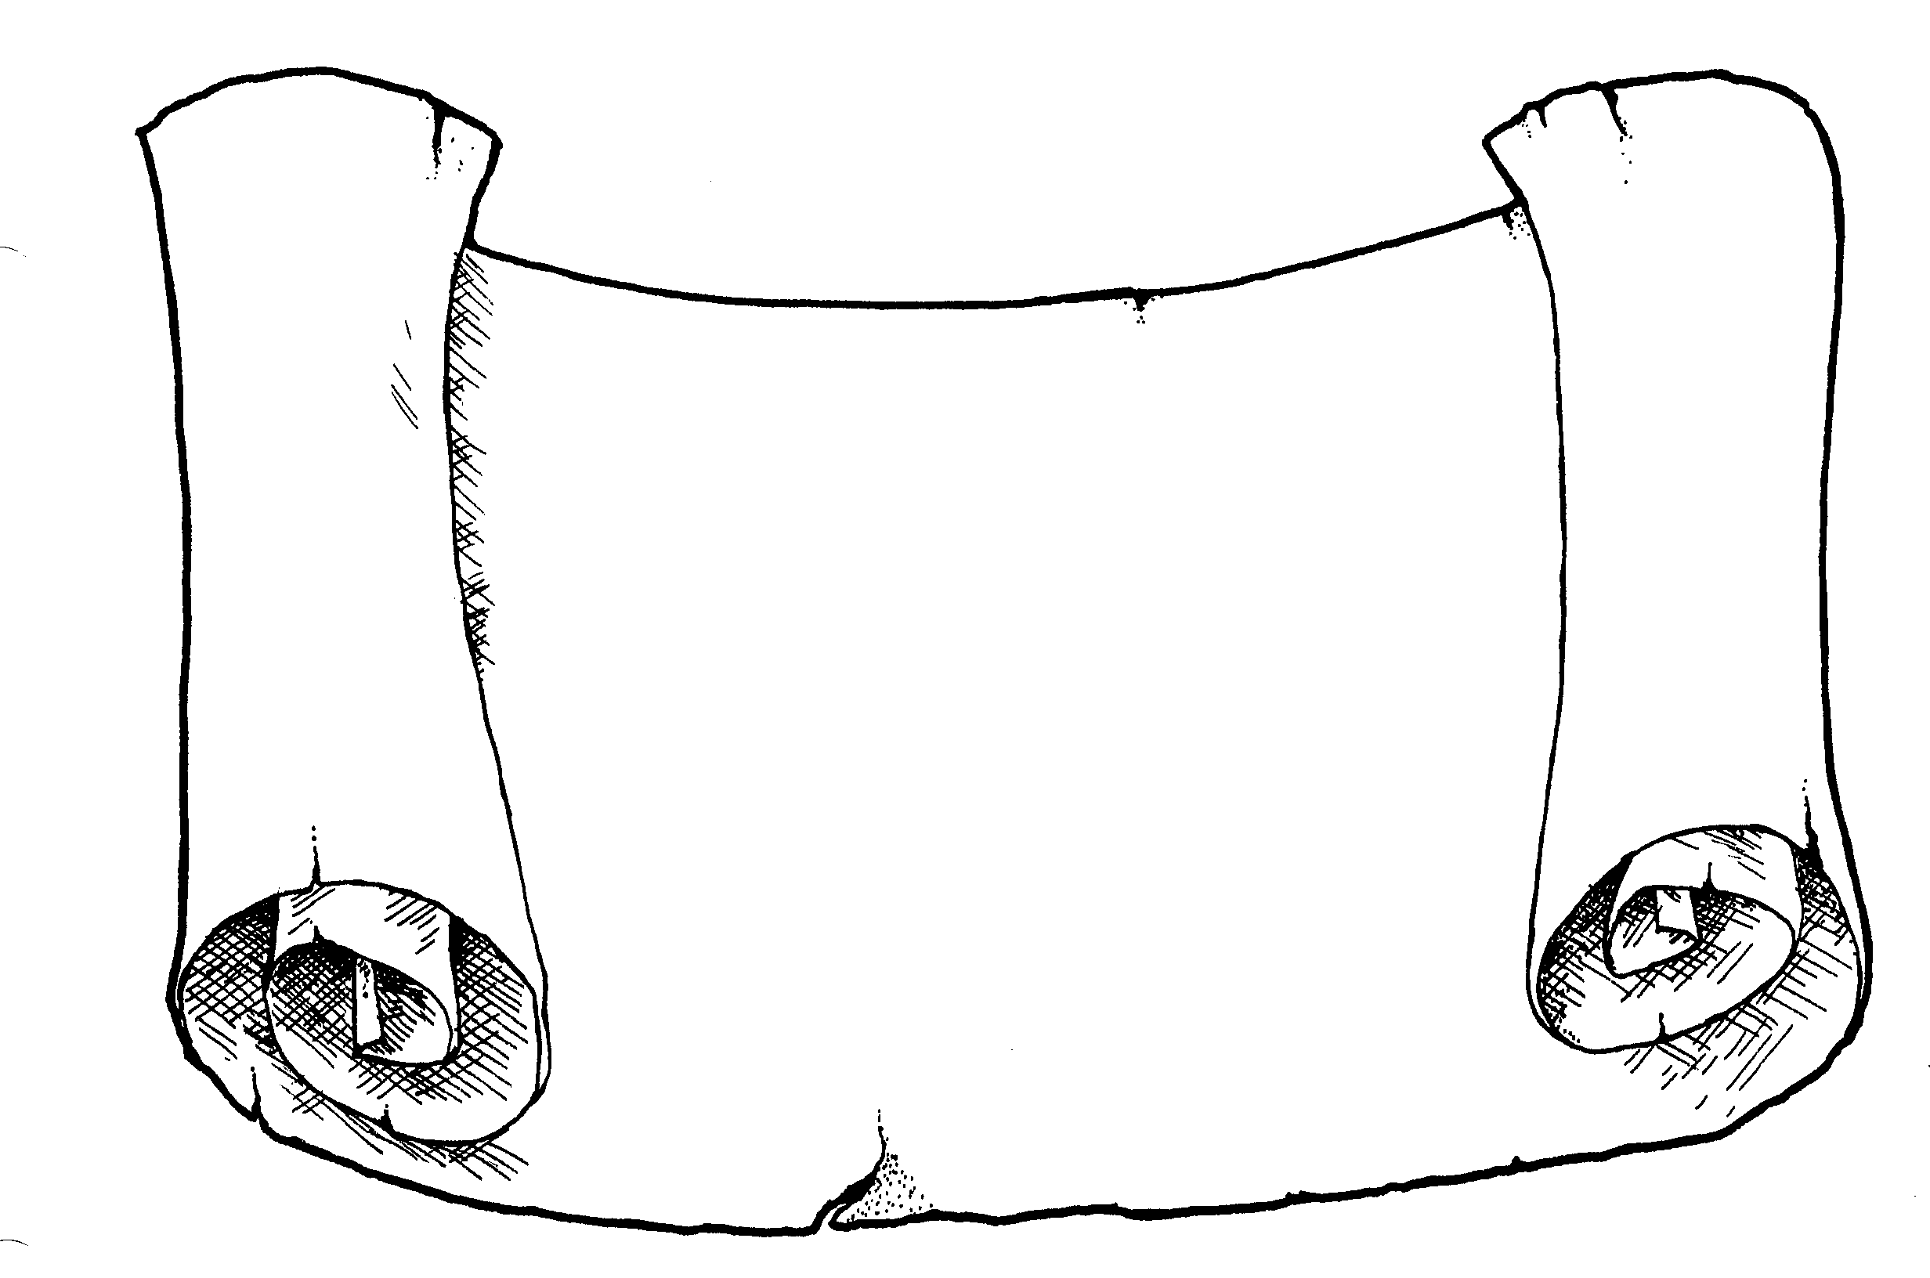
Is the Torah scroll holy to Jewish people?

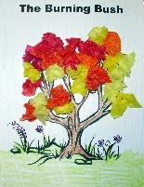
- Find out about the story of Moses and the burning bush.
Watch this video: https://www.youtube.com/watch?v=omn08jyfN3s
Make a model or draw a picture of the burning bush.
Think about this question: Do you think that the place of the burning bush is holy ground for Jewish people? What is your reason for thinking this?

- Investigate what happened next to Moses. You can find information at this website:
https://www.topmarks.co.uk/judaism/story-of-moses
You could draw and write about his story in a comic strip or mini-booklet.

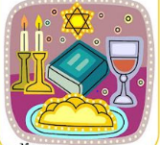
- Investigate the Jewish Shabbat and how it is celebrated.
There is some information at this website: https://kids.kiddle.co/Shabbat
You can watch this video to see a Jewish family celebrating Shabbat:
https://www.bbc.co.uk/bitesize/clips/zvtfgk7
You could present your findings in a PowerPoint presentation or fact file.
Consider this question: Is ‘holy’ a good word to describe the time of Shabbat?

- In the Torah, it says: Be holy, because I, the Lord you God am holy. For Jewish people, it is important do what the Torah says; it is God’s law and God is the King so these are like royal decrees.
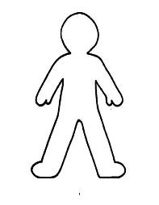
Thinking about what you have found out about the Jewish beliefs, what do you think would make a person holy?
You could on an outline of a person, draw and write what holiness would look like in someone’s life. What sort of things would we see them doing?

