Lesson 1-How do rules and laws keep us safe?
Talk to your grown up, what is a rule and what is a law? Are they similar or different? Why do we have them? Where do you see rules? Who creates rules? Who creates the laws?
Task 1- Fill out the following speech bubble (you could even decorate it if you like).
We have rules and laws because…
__________________________________
__________________________________
__________________________________
__________________________________
__________________________________

Task 2- Below is a map of a town called Uptown. The town is on the planet Zog. There are no rules and laws which is making the town unsafe and very disorganised. Can you think of some rules and laws for this town? (Again, feel free to colour this in once you have finished the task).
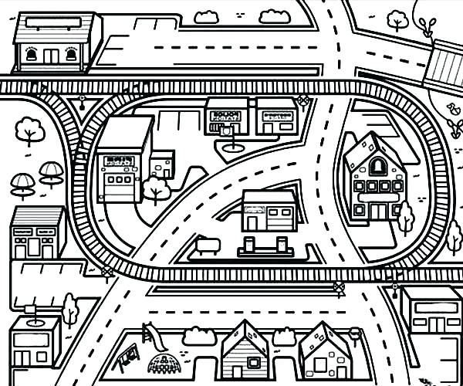
Rules and laws for Uptown:

