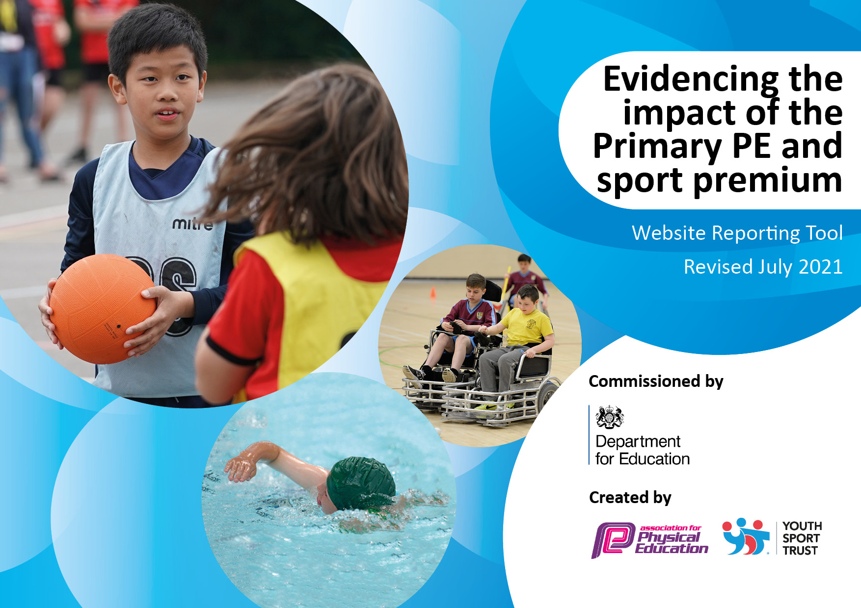
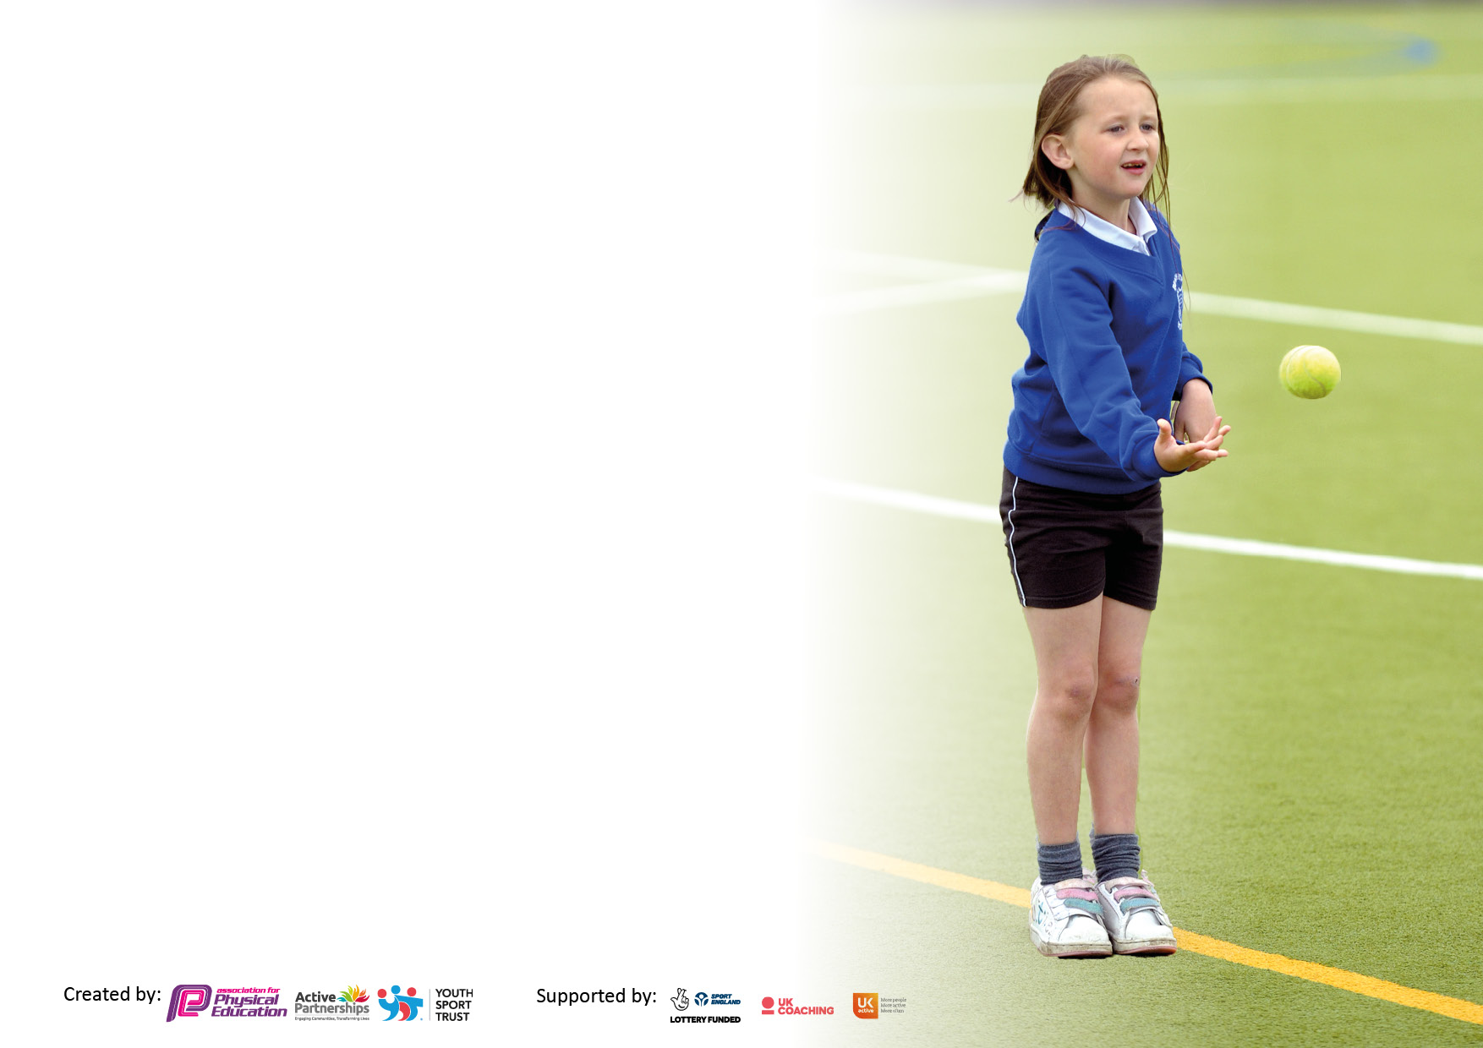

It is important that your grant is used effectively and based on school need. The Education Inspection Framework makes clear there will be a focus on ‘whether leaders and those responsible for governors all understand their respective roles and perform these in a way that enhances the effectiveness of the school’.

Under the Quality of Education Ofsted inspectors consider:
Intent - Curriculum design, coverage and appropriateness
Implementation - Curriculum delivery, Teaching (pedagogy) and Assessment
Impact - Attainment and progress

To assist schools with common transferable language this template has been developed to utilise the same three headings which should make your plans easily transferable between working documents.

Schools must use the funding to make additional and sustainable improvements to the quality of Physical Education, School Sport and Physical Activity (PESSPA) they offer. This means that you should use the Primary PE and sport premium to:

- Develop or add to the PESSPA activities that your school already offer
- Build capacity and capability within the school to ensure that improvements made now will benefit pupils joining the school in future years
- The Primary PE and sport premium should not be used to fund capital spend projects; the school’s budget should fund these.

Pleasevisitgov.ukfortherevisedDfEguidanceincludingthe5keyindicatorsacrosswhichschoolsshoulddemonstrate animprovement.Thisdocumentwillhelpyoutoreviewyourprovisionandtoreportyourspend.DfEencouragesschools to use this template as an effective way of meeting the reporting requirements of the Primary PE and sport premium.

We recommend you start by reflecting on the impact of current provision and reviewing the previous spend.

Schools are required to publish details of how they spend this funding, including any under-spend from 2019/2020, as well as on the impact it has on pupils’ PE and sport participation and attainment. All funding must be spent by 31st July 2022.

We recommend regularly updating the table and publishing it on your website throughout the year. This evidences your ongoing self-evaluation of how you are using the funding to secure maximum, sustainable impact. Final copy must be posted on your website by the end of the academic year and no later than the 31st July 2021. To see an example of how to complete the table please click HERE.

Details with regard to funding
Please complete the table below.

Total amount carried over from 2019/20 | £4,496
Total amount allocated for 2020/21 | £18,914
How much (if any) do you intend to carry over from this total fund into 2021/22? | £11,247
Total amount allocated for 2021/22 | £18,929
Total amount of funding for 2021/22. To be spent and reported on by 31st July 2022. | £30,176
Swimming Data
Please report on your Swimming Data below.

Meeting national curriculum requirements for swimming and water safety.

N.B. Complete this section to your best ability. For example you might have practised safe self-rescue techniques on dry land which you can then transfer to the pool when school swimming restarts.
Due to exceptional circumstances priority should be given to ensuring that pupils can perform safe self rescue even if they do not fully meet the first two requirements of the NC programme of study
What percentage of your current Year 6 cohort swim competently, confidently and proficiently over a distance of at least 25 metres?  N.B. Even though your pupils may swim in another year please report on their attainment on leaving primary school at the end of the summer term 2020.  Please see note above | 80%
What percentage of your current Year 6 cohort use a range of strokes effectively [for example, front crawl, backstroke and breaststroke]?  Please see note above | 78%
What percentage of your current Year 6 cohort perform safe self-rescue in different water-based situations? | 73%
Schools can choose to use the Primary PE and sport premium to provide additional provision for swimming but this must be for activity over and above the national curriculum requirements. Have you used it in this way? | No

Action Plan and Budget Tracking
Capture your intended annual spend against the 5 key indicators. Clarify the success criteria and evidence of impact that you intend to measure to evaluate for pupils today and for the future.

Academic Year: 2020/21 | Total fund allocated: £18,914 | Date Updated: 28/07/2021
Key indicator 1: The engagement of all pupils in regular physical activity – Chief Medical Officers guidelines recommend that primary school pupils undertake at least 30 minutes of physical activity a day in school |  |  |  | Percentage of total allocation:
 |  |  |  | 31%
Intent | Implementation |  | Impact
Your school focus should be clear what you want the pupils to know and be able to do and about  what they need to learn and to  consolidate through practice: | Make sure your actions to achieve are linked to your intentions: | Funding allocated: | Evidence of impact: what do pupils now know and what can they now do? What has changed?: | Sustainability and suggested next steps:
To target and increase the number of opportunities for the least active children to participate in physical activity and school sport. | Personal Best - Physical Education and Physical Activity Interventions.  Targeted support for children with low levels of PE and school sport engagement. Focusing of achieving their own personal best to engage, motivate and inspire them to fully participate in Physical Education and Sport and become more physically literate. | £874.96 | See impact report | The data collected shows that this programme has worked well in supporting children with low levels of PE and school sport engagement. For the next academic year, we will look at how we can do this on a larger scale to help support all children.
 | Family Engagement Karate after school physical activity sessions.  This programme of physical activity  is aimed at children and their parents with a view to increasing the enjoyment of physical activity, leading to sustained participation. | £325 | Delivery postponed until academic year 20/21 due to covid-19.
• Increase daily activity and physical challenge for all pupils by creating a stimulating, exciting and inclusive playground.  • Offer alternative activities at lunchtime that can be used as part of the daily fitness programme (wake up shake up)  • Improve pupils co-ordination, teamwork and leadership skills | Investment of Playground Equipment | £1363 | • pupil voice  • engagement  • feedback from staff  • improvement in ability to complete personal best competitions  • Improvements in behaviour should also be noticeable due to increased fun and engagement in activity at playtimes. | PE/Sport leaders to be re-established to help look after the equipment while providing the children with opportunities to lead and officiate their own games.
To deliver high quality PE lessons and maintain engagement in activity. | Purchase of new equipment and the  annual maintenance costs for  existing equipment | £4730.83 | Staff comments “The quality of my lessons have improved so much by having more equipment available. By having a ball each in games like football or basketball the children get more practise time and in turn more time to develop the skills and learning. | • Increased ability to differentiate due to increased equipment  • Increased enjoyment of lessons  • CS to communicate with teachers to find out what equipment they would like. This will give teachers more autonomy of what they want to teach.
Key indicator 2: The profile of PESSPA being raised across the school as a tool for whole school improvement |  |  |  | Percentage of total allocation:
 |  |  |  | 9%
Intent | Implementation |  | Impact
Your school focus should be clear what you want the pupils to know and be able to do and about  what they need to learn and to  consolidate through practice: | Make sure your actions to achieve are linked to your intentions: | Funding allocated: | Evidence of impact: what do pupils now know and what can they now do? What has changed?: | Sustainability and suggested next steps:
-To provide a clear vision for PE and school sport at Mount Primary.  - Establish and analyse teaching strengths and identify areas for improvements to ensure all children achieve and make progress.  - Develop clarity on the approach to lead, manage and implement high quality teaching and learning in PE at Mount Primary school. | Subject leads Teaching and Learning Responsibility Payment  Raise the profile of PE and Sport in school by leading events and initiatives that excite and motivate pupils and staff.  Subject lead focus  -Develop a curriculum that is in line with the new Ofsted framework.  -Ensuring high quality teaching and assessment of PE  -Establish a more effective way of assessing PE across the key stages | £2000 | See subject leader action plan | To identify how PE, school sport and physical activity can contribute to areas identified in the school improvement plan.

Key indicator 3: Increased confidence, knowledge and skills of all staff in teaching PE and sport |  |  |  | Percentage of total allocation:
 |  |  |  | 6%
Intent | Implementation |  | Impact
Your school focus should be clear | Make sure your actions to | Funding | Evidence of impact: what do | Sustainability and suggested
what you want the pupils to know | achieve are linked to your | allocated: | pupils now know and what | next steps:
and be able to do and about | intentions: |  | can they now do? What has
what they need to learn and to |  |  | changed?:
consolidate through practice:
At Mount Primary school we aim to provide a high quality PE, school sport and physical activity provision for all children. In order to this we need to increase staff confidence and knowledge when teaching PE and ensure teachers have access to high quality planning that ensures progression of skills across the key stages. | Curriculum support Programme  The programme ran over the course of 6 weeks. During this time, staff have had the opportunity to: observe high‐quality PE sessions; the opportunity to team teach with a PE specialist and the opportunity to plan and deliver their own PE sessions with the help and support of a PE specialist. | £875 | Staff quote – “I have a better understanding of how to build up the skills within a lesson.” Prior to the training the staff member was asked. How confident did you feel about teaching PE before the Programme (1 – Not confident at all / 5 – Very confident): and graded themselves as a 2. After the training they were asked,  how confident did you feel about teaching PE after the Programme (1 – Not confident at all / 5 – Very confident): and they said  4. | The data shows that this is an effective use of spending. It is important that we make this CPD available to more teachers. CS to communicate with edsential to use a model where all teachers receive PE CPD rather than just 2.
1. Effective and efficient Leadership and Management of Physical  Education, Sport and Physical Activity  2. Raising standards of Teaching and Learning in Physical Education | PE Passport  Central evidence hub for all ‘Personal Development’ activities across the school. | £432 | Easily track and monitor Curriculum and Extra-curricular data to allow prompt interventions.  Identify and report key trends and gaps in provision | PE lead (CS) to analyse data collected to identify trends and share with SLT.  Provide detailed information for staff to allow them to access the PE plans and assessments.
1. Engaging all pupils in a high-quality and relevant Physical  Education curriculum  2. Attainment of pupils in Physical Education, including physical,  cognitive, social and emotional aspects  3. Raising standards of teaching and learning in Physical Education | PE Scheme of work  The structure of the Scheme of Work allows us to teach in a way, which suits our needs and aims. | £200 | Staff comments: “The online planning makes teaching PE easier and less time consuming.”  “I like the PE planning because the lesson objectives are clear and the activities are easily adapted.” | CS to complete curriculum design by the end of the autumn term of the 2021/2022 academic year.
Key indicator 4: Broader experience of a range of sports and activities offered to all pupils |  |  |  | Percentage of total allocation:
 |  |  |  | 25%
Intent | Implementation |  | Impact
Your school focus should be clear | Make sure your actions to | Funding | Evidence of impact: what do | Sustainability and suggested
what you want the pupils to know | achieve are linked to your | allocated: | pupils now know and what | next steps:
and be able to do and about | intentions: |  | can they now do? What has
what they need to learn and to |  |  | changed?:
consolidate through practice:
The child obesity levels in the area that Mount primary is located, is higher than the national average. By working with the children we can identify activities that they would like to participate in which will enhance their sports development and their health and fitness. | Qualified sports coaches to run activities each lunchtime with an aim of targeting focus children with low engagement levels.  Children encouraged to try and experience new sports and activities with the aim of developing personal and social skills. | £2912 | See PE Lead action plan | As a school, we have decided to move away from using sports coaches at lunchtime. CS to work with TA staff who supervise the children on the playground at lunchtimes to help create an active and engaging playground. SLT and business manager to appoint a new member of staff employed by the school in a play leader role.
 | Additional after school club – delivered by a PE specialist with the aim of increasing participation in the extracurricular provision by increasing the variety of activities on offer. | £300 | Delivery postponed until academic year 20/21 due to covid-19.
 | Judo session  Designed to give the year 6 children an experience of a sport/activity that they had not experienced before. | £150 | Pupil comment: “That was so much fun! I have always wanted to try martial arts and that is something I will do again.”  “I think Judo is something that would help me keep fit and become more confident. I’m going to ask my dad if I can go to a judo club.” | Establish through pupil voice if this is a sport the children would like to do as an after school club.
To support the year 6 children in bringing their physical and emotional body into balance to restore health and wellbeing before they transition to secondary school. | Rainbow Programme  The year 6 children took part in a 3-week programme that utilised Growth Mindset, Mindfulness, Yoga and Yoga Therapy. A qualified yoga therapist/yoga teacher delivered the programme.  The children were taught about brain health, resilience, coping with difficult emotions, trust, support and being a leader of themselves.  Overall, and in a gentle way, this programme taught the fact that ‘nothing stays still’, everything in life changes. This can be challenging, especially in difficult times, but it’s inevitable and the more adaptable we are, the easier it is to cope. | £450 | Pupil comments:  “It has helped me to stay calm. I have done the routine to help my Dad with stress, anger & nerves. Thank you.”  “I am usually really stressed, the yoga really helped me. It was a nice way to say to myself that I am in control of myself and to calm me down, the different positions will stick with me forever. “  “I usually struggle to sleep, this week I did what we learnt during the relaxation and I have fallen straight to sleep each night.”  “The yoga helped me find my inner peace.” | CS to speak to the Y5-6 team to establish if this is something they would like the children to do prior to the year 6 SATs as it may help the children to manage their emotions during a challenging time.
Develop children’s physical, social and behavioural skills.  Introduce children to the discipline of competitive sport and the ethos of sportsmanship.  Enhance children’s sports development, health and fitness. | Rugby Tots  The children took part in a programme designed to develop their emotional skills focusing on becoming better self-managers,  team workers and effective participators. While also developing their physical skills focusing on ball handling, agility, spatial awareness and health & fitness. | £1950 | See impact report

Key indicator 5: Increased participation in competitive sport |  |  |  | Percentage of total allocation:
 |  |  |  | 0%
Intent | Implementation |  | Impact
Your school focus should be clear | Make sure your actions to | Funding | Evidence of impact: what do | Sustainability and suggested
what you want the pupils to know | achieve are linked to your | allocated: | pupils now know and what | next steps:
and be able to do and about | intentions: |  | can they now do? What has
what they need to learn and to |  |  | changed?:
consolidate through practice:
Due to the covid-19 pandemic, opportunities to participate in competitive school sport has been restricted. We value the importance of competitive school sport and |  | £ | Collaboration with Wallasey Alliance schools has created opportunities  for pupils across ages to participate in a wide range of competitive  sporting activities. Participation levels were impacted by covid-19. | CS to focus on this key indicator when restrictions have lifted.

Signed off by
Head Teacher:
Date:
Subject Leader: | C. Swatman
Date: | 28/07/2021
Governor:
Date:

