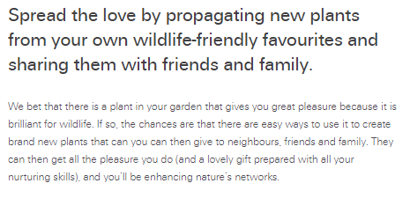

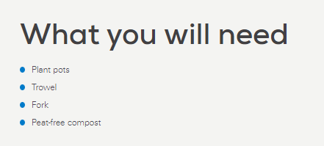

Step by step
Here are the easiest ways to create new plants from old:
- Seeds. Not every type of garden plant produces viable seeds, but many do, so as the flowers go over, whether that be in spring, summer or autumn, watch for the seedcases to mature. Some seeds are large – those produced in pods are some of the easiest to collect, as you can take then to shell indoors out of the wind. Other seeds are tiny, and the best method is to take a brown paper bag, pop it over the seedhead, which you then cut off, turning the bag upside down to allow the seeds to drop out. With many plants, you can sow the seed immediately. For small seeds, scatter them thinly onto a tray or pot of sieved compost; for larger seeds that are easier to handle, plant them in drills in trays of compost; and for really large seeds, sow them individually, one to a small plant pot. It is good practice with most seeds to cover with a thin layer of horticultural grit. Water them and put them somewhere outside that is sheltered but not hot. Some will germinate quite quickly and produce seedlings that autumn; others may benefit from being left outside to experience winter’s cold, which is what some seeds need to prompt them to grow in spring.
- Seedlings. Some plants are so keen to grow that their seedlings pop up all over your flower beds. Teasels, foxgloves, Verbena bonariensis, poppies – they all like to spread themselves. Instead of weeding them out for the compost, carefully lift them with a fork or trowel, keeping as much root as possible intact, and pot up immediately into peat-free compost. Water them, and put them somewhere where they won’t get baked by the sun, for they are bound to be a little bit shocked by the move and will need time to ‘find their feet’ again. Pretty soon, they’ll be fit new plants ready to give away.
- Cuttings. Some people think that there must be a dark art to taking cuttings, but in reality it is quite simple. Sure, some cuttings will ‘take’ and others won’t, but just celebrate your successes. Everything from flowering shrubs to climbers to many garden border plants will happily form a new plant from a few inches of cut stem. The technique is the same for almost all cuttings – cut a length of stem without flowers about the length of a pencil. Trim it neatly just below a node (the point where the leaves branch from the stem), and cut off the lower leaves to give you a bare stem. Plunged it down the side of a pot into gritty, free-draining soil. Water, and keep well watered but not waterlogged. Soon, it should start to put down roots and the leafy tips will show signs of green growth. When using fresh, leafy plant material, it can help to put a plastic bag or cut off bottom of a clear plastic drinks bottle over the top like a mini cloche. The new cutting has no roots at first to draw up water, and so this helps stop it from wilting.
- Divisions. This is perhaps the easiest method of all for creating new plants. It is suitable for a wide range of clump-forming perennial plants. If your plant is a few years old and pretty chunky, then dig up the clump in spring or autumn and break it into three, four, five or even more smaller parts. Some plants tease apart quite easily; others need to be cut through cleanly with a spade or prised with two forks back to back. The smaller parts actually love the ‘freedom to breathe’ and soon bulk up into new plants. Good wildlife-friendly flowers to try include Agapanthus, Eryngium (sea holly), Euphorbia, Geranium, Helianthus, Iris, Lysimachia, ornamental grasses, Primula, Salvia and Sedum.

