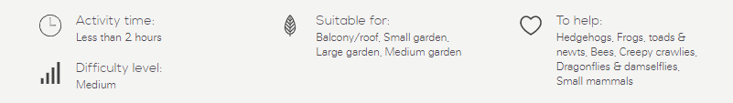
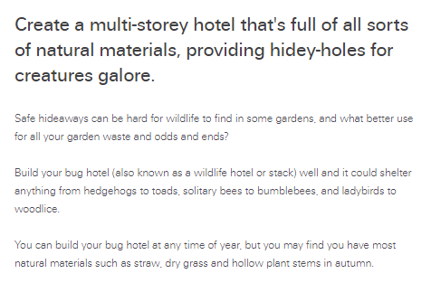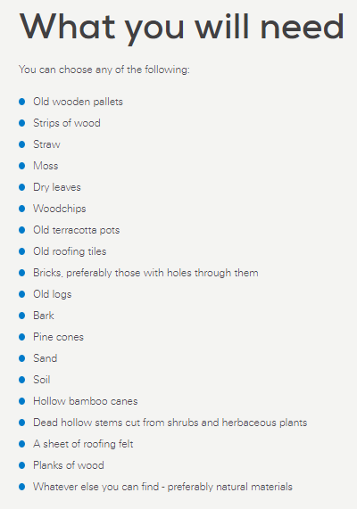

Step-by-step guide
- Choose a suitable site. It needs to be level and the ground firm.
You’ll get different residents depending on where you place your hotel, as some like cool, damp conditions and others (such as solitary bees) prefer the sun. If you have vegetable beds, keep it a good distance away from them.
The basic structure. You will need a strong, stable framework that's no more than a metre high!
Old wooden pallets are perfect for a large hotel as they’re sturdy and come with ready-made gaps. Start by laying some bricks on the ground as sturdy corners. Leave some spaces in between the bricks – try creating an H-shape. Add three or four layers of wooden pallets on top of your bricks. If you leave larger ends, you’re more likely to attract hedgehogs.
You can also make a smaller structure, depending on the wood and space you have.
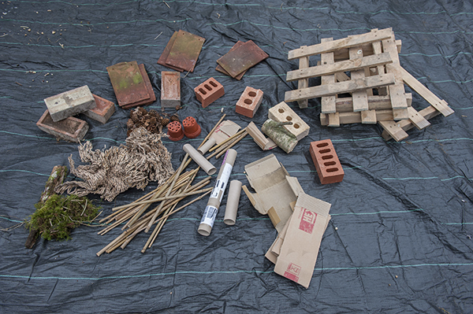
- Fill the gaps. The idea is to provide all sorts of different nooks and crannies, crevices, tunnels and cosy beds.
Include:
- dead wood and loose bark for creepy crawlies like beetles, centipedes, spiders and woodlice
- holes and small tubes (not plastic) for solitary bees made out of bamboo, reeds and drilled logs
- larger holes with stones and tiles, which provide the cool, damp conditions frogs and toads like – if you put it in the centre you’ll give them a frost-free place to spend the winter (they’ll help eat slugs)
- dry leaves, sticks or straw for ladybirds (they eat aphids) and other beetles and bugs
- corrugated cardboard for lacewings (their larvae eat aphids, too)
- dry leaves which mimic a natural forest floor
- you can even put a hedgehog box into the base of the hotel.
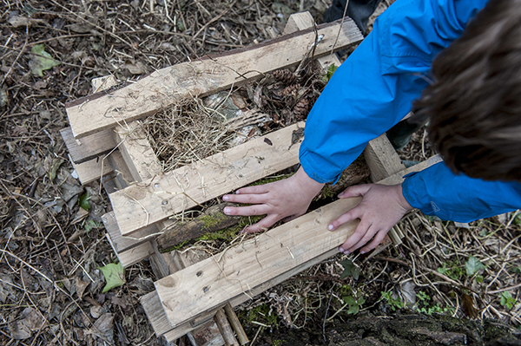
- Add a 'roof'. When you think you've gone high enough, making sure the stack remains stable, put a roof on to keep it relatively dry. Use old roof tiles or some old planks covered with roofing felt.
You could even give it a 'green' or 'brown' roof by putting a bit of rubble or gritty soil on top. Only plants that love dry conditions cope up there, but some wild flower seeds could arrive on the breeze and take root.
Surround your hotel with nectar-rich flowers – essential food for butterflies, bees and other pollinating insects.
If you want, choose a name for your hotel and put a sign up outside. Children will get a thrill from making their first home.
Please take a photo, and post it to inspire others. Most activity in your hotel is likely to be after dark in the warmer months, so go out with a torch to see who is popping in and out.
