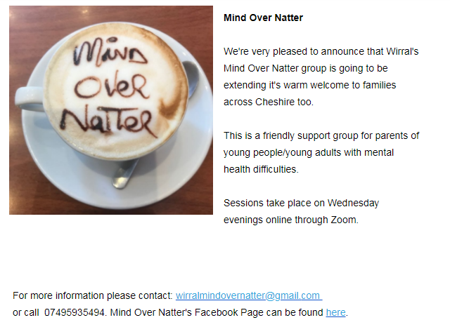
Facebook link: https://m.facebook.com/wirralmindovernatter/

