How to keep mentally healthy during uncertain times
25 Mar 2020 | Adrian Bethune & Frederika Roberts
Looking after your mental health is vital, especially when you're stuck at home
We're entering unprecedented times with this Coronavirus pandemic. No one knows how it is going to pan out or how long it is going to last for. An unintended consequence is that our mental health may suffer as we keep apart from our families, friends, neighbours and colleagues.
The good news is there are lots of positive things we and our families can do to stay as physically and mentally healthy as possible.

1. Keep active
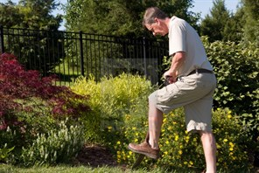
When we are physically active, it keeps our bodies healthy, our immune system strong and our minds in tip top condition. Physical activity burns off stress hormones like cortisol so we feel calm, centred and energised. Why not try:
- Cleaning your house actually counts as 'moderate' activity - so get tidying and not only will you have a work out, you'll have a clean house too!
- Break your day up with short bursts of star-jumps, press-ups or running on the spot.
- Get active with your kids - www.bbc.co.uk/teach/supermovers and www.gonoodle.com are free to use and great fun!

2. Immerse yourself in nature
Research shows that nature can have a healing effect on our minds and bodies. One study showed that patients recovering from surgery whose beds overlooked a garden recovered faster than those whose bed overlooked a carpark. Try these:
- If you have a garden, start tidying it ready for spring.
- Take care of any house plants - feed, water and prune them.
- If it's safe to do so, spend some time in a local wood and bathe in the natural world.

3. Focus on the present
Our minds have a tendency to ruminate on the past, or fast-forward to the future, sometimes in a negative kind of way. This tendency is often exacerbated during times of stress. An antidote is to intentionally focus on the present moment - by noticing what's happening in our minds, bodies and the external environment with an attitude of kindness and curiosity.
- Place one hand on your belly and one hand on your chest and, as you breathe normally in and out through your nose, count 10 full breaths.
- Download and try one of the many free mindfulness apps like www.headspace.com
- If you find your mind racing, lie down and tune in to the sensations in your body.

4. Laugh
Laughing feels good, boosts our immune system and helps us keep things in perspective. Laughing with others strengthens relationships and, because laughter is contagious, we laugh more with others.
- Share jokes at home and online.
- Watch funny clips and films.
- Try laughter yoga; there are plenty of examples on YouTube. There is some research evidence that even fake or forced laughter can improve mood and wellbeing.

5. Practise kindness
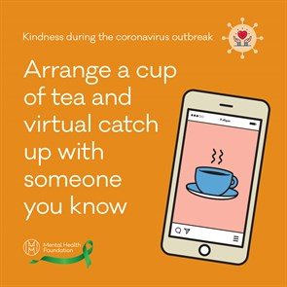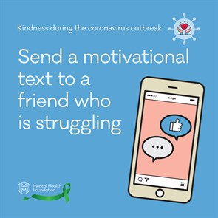
In times of need, we often see the best of humanity as people dig deep to help others.
- Offer to pick up supplies for self-isolating neighbours and maybe now is the time to donate some money to charity.
- Be extra kind to others in your house. Tensions can run high when we feel trapped inside. Make cups of tea, give hugs (if you're allowed to!), pay compliments.
- Reach out to friends and family and let them know you're thinking of them. Pick up the phone or have a video call with grandparents so they feel connected.

6. Focus on what's good
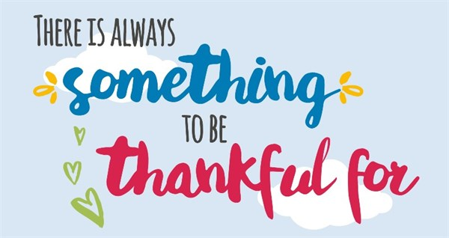
There is ample research to show that deliberately focusing on the good things in our lives - practising gratitude - can improve our wellbeing. It's easy to give in to our natural 'negativity bias' as our brains strive to protect us from harm, but we can counter that by deliberately focusing on what's good, even during challenging times.
- At the end of each day, write down three good things about the day, no matter how small (a rainbow in the sky, another day without symptoms, a funny joke you heard…it's amazing what you'll notice when you pay attention!).
- Share at least one positive story with other people each day.
- Say 'thank you' for all the little things others do for you and mean it.

7. Keep learning
Our minds need challenge and stimulation to stay healthy, which is why learning new things is one of the Five ways to wellbeing.
- All those books you don't have time to read? Read them. Read them all!
- Take an online course. Now could be the perfect time to learn a new skill and there are lots of great free courses on sites like www.coursera.org andwww.edx.org
- Children can research a topic they're interested in, then share five ideas or facts they learned with someone else. Use the BBC learning website www.bbc.co.uk/learning/subjects/childrens_learning.shtml

8. Connect
Connecting with others is another of the 'five ways to wellbeing'. Research shows that people who have the richest social relationships are the happiest; the quality of relationships has even been linked to physical health and longevity (and academic achievement in children). Social distancing doesn't mean you can't keep in touch. Let people know you care and especially contact those who may be more isolated or lonely.
- Each day, contact one person you haven't spoken to for some time.
- Make use of technology like WhatsApp video call, facetime, Zoom and Skype friends and family to stay in touch.
- Notice positive qualities in other people (e.g. strengths such as perseverance, kindness, being hopeful etc) and compliment them on those.

9. Concentrate on strengths
Character strengths are essential in supporting wellbeing. Research (see VIA Institute on Character) shows that recognising and working with our strengths increases our levels of happiness.
- Identify your top five strengths and consider how these can help you navigate these challenging times.
- Challenge family and friends to use a particular character strength in new ways.
- Watch a film or read a book, then discuss with others the strengths shown by different characters in the story.

Remember, nothing lasts forever, no matter how bad it is or feels at the time. Human beings often grow and flourish through adversity.
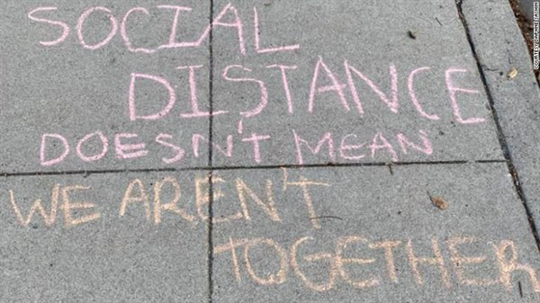
This is an incredibly challenging time, but we are all in this together and we can take this opportunity to rediscover our shared humanity.

