Impact of the Primary PE and Sport Premium Spending Report 22-23
What percentage of your current Year 6 cohort swim competently, confidently and proficiently over a distance of at least 25 metres? |  |  | 85%
What percentage of your current Year 6 cohort use a range of strokes effectively [for example, front crawl, backstroke and breaststroke]?  Please see note above |  |  | 80%
What percentage of your current Year 6 cohort perform safe self-rescue in different water-based situations? |  |  | 80%
Schools can choose to use the Primary PE and sport premium to provide additional provision for swimming but this must be for activity over and above the national curriculum requirements. Have you used it in this way? |  |  | No
Total allocated spend for 2022-23 – £36,067
KS1 playground- £16,914
Total Spent- 35,877
Key indicator 1: The engagement of all pupils in regular physical activity – Chief Medical Officers guidelines recommend that primary school pupils undertake at least 30 minutes of physical activity a day in school
Spending | Impact | Next Steps
£10070  S4YC sports Coach Monday and Wednesday | All children will have an additional hour of active PE each week through our Wake Up Shake Up programme. This will help us to obtain the recommended 2 hours each week and will have a beneficial impact on children’s mental health and wellbeing, physical health and concentration levels in class.  A well-structured, active lunchtime provided with more children engaging with sport and physical activity. 100% of all children have participated in an extra-curricular club this year (including lunchtime clubs).  Offer a variety of extra-curricular clubs.  CPD to staff by supporting them with the curriculum.  Targeted PE interventions used to improve progress and attainment in PE  Staff feedback/Pupil Survey | Introduction of new PE assessment tool which will help to monitor progress and attainment across all year groups. Sports coach will be trialling the use of IPEP.  Timetable to be changed each term to ensure PE CPD is offered to as many staff as possible.  Sports coach to continue providing the children with active lunch times (change up the sports/games each half term to provide children with wider experiences)  Extra-curricular clubs to continue to be tracked. Key children identified.  Pupil voice questionnaire- what do they want?
£795  Fundamentals Programme  6 X ½ days | This programme supports  - Pupils with poor gross motor skills  - Physical literacy of less active pupils  - Pupils attaining Age Related Expectations at end of KS1  - Following the programme, there was a 9% increase in the number of children | We will continue to offer this programme to our Y6 children.
Key indicator 2: The profile of PESSPA being raised across the school as a tool for whole school improvement
£2873  PE Lead TLR  Focus areas  -To provide a clear vision for PE and school sport at Mount Primary.  - Ensure a wider offer is in place for all children, giving them access to a range of extra-curricular opportunities that promote physical and mental wellbeing. | Organisation of clubs and competitions. Risk assessments etc.  Organising CPD for staff  Quality assuring staff- supported staff where necessary.  Audits of equipment  92% of all children have participated in an after-school extra-curricular club.  94% of all SEND children have participated in an after-school extra-curricular club.  95% of all pupil premium children have participated in an after-school extra-curricular club. | Continue to work closely with the school office to track participation in extra-curricular clubs. This has helped to ensure that access the extra-curricular provision is fair for all children. Pupil premium and SEND children to continue to be a focus.  Staff questionnaire following CPD- do they now feel more confident teaching…?  Continue with links to LFC Foundation coaches to provide further CPD opportunities.  Introduce new planning (iPeP) as we get it for free with the S4YC coaches. Ensure quality and staff are happy with it. CPD to be provided.  Target children who are not accessing extra-curricular clubs with a possible lunchtime club.
Key indicator 3: Increased confidence, knowledge and skills of all staff in teaching PE and sport
£300  PE Scheme of work  The structure of the Scheme of Work allows us to teach in a way, which suits our needs and aims. | Easy to ensure progression across key stages and all year groups. Less confident staff have ready-made planning that they can tailor to their class needs.  Staff comments:  “The improvements that edsential have made to plans are really useful.”  “I am confident at teaching PE so I use the knowledge mats for each unit of work”  “The plans are a good guide and easy to adapt.”  “Sometimes I find the activities hard to understand”  “The assessment tools are tick sheets which increase teacher workload with minimal impact on the children”  Pupil voice- ‘I have enjoyed my PE lessons as we get to play lots of different games.’  ‘I have enjoyed learning about dances from different parts of the world’  ‘PE is fun’ | PE lead to use pupil voice, staff questionnaires and observations to ensure all teachers are confident following plans and progression documents.
£700  Subject leader support programme. | As a new subject leader, the support I have received this year has been invaluable in helping myself to develop into the role and understand the multidimensional aspects of PE and Sport in schools.  Includes  PE and Sport Premium advice, action plans, learning walks and observations, policy writing and school website guidance and compliance  Termly in school/online update meeting  Termly newsletter including ‘Tasks for the Term’, useful resources and updates on national and local guidance.
Key indicator 4: Broader experience of a range of sports and activities offered to all pupils
£600  Karate Club  Autumn- Y5/6  Spring- Y3/4  £650  After school Tennis club delivered by Thorndale Tennis Club  £150  Tennis Workshop for all year groups | School improvement focus  Ensure a wider offer is in place for all children, giving them access to a range of extra-curricular opportunities that promote physical and mental wellbeing.  Autumn 1- Y5/6  Autumn 2- Y1/2  100% of children given the opportunity to experience tennis and signposted to clubs they could attend in the local area. | Continue to track clubs to ensure a good variety to each year group. KS2 have had an excellent variety of sports- KS1 would be a focus to ensure consistency across the school.  Incentivise staff to run a club with TOIL.  By working with Thorndale Tennis club they delivered 4 free competitions that were held at the tennis club.
£875 (This includes a 6 week after school club programme for Y5/6)  Rainbow Programme  The year 6 children took part in a 3-week programme that utilised Growth Mindset, Mindfulness, Yoga and Yoga Therapy. A qualified yoga therapist/yoga teacher delivered the programme. | The children were taught about brain health, resilience, coping with difficult emotions, trust, support and being a leader of themselves. This was delivered in the same term as SATs  Impact Report:  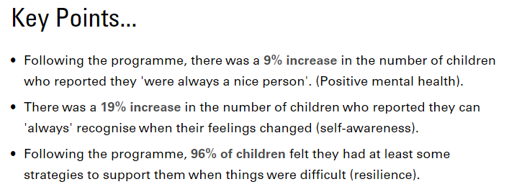  Pupil voice  - The breathing techniques helped me to sleep at night.  - Helped me to relax and calm down.  - The programme helped me when I’m angry to calm  - The programme helped me when I’m angry to calm myself.  - Doing yoga helped me with my back.
£1950  Rugby Tots  The children took part in a programme designed to develop their emotional skills focusing on becoming better self-managers,  team workers and effective participators. While also developing their physical skills focusing on ball handling, agility, spatial awareness and health & fitness. | Before  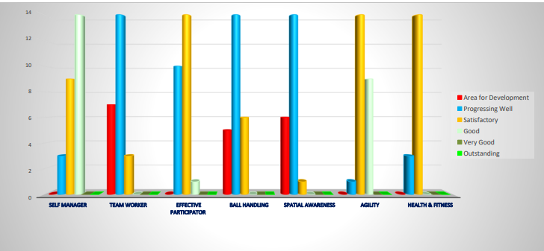  After  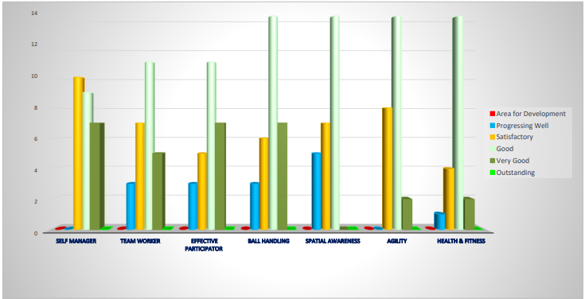  See the full impact report for more details | EYFS teachers are happy with the service provided. CPD has now been provided.
Key indicator 5: Increased participation in competitive sport
Football x2 Houlihan Cup (Y6)  Corgi Cup-( Y4/5)  Tennis Tournament at Thorndale Tennis Club (Y1/2)  Tennis Tournament at Thorndale Tennis Club (Y3/4)  Tennis Tournament at Thorndale Tennis Club (Y5/6)  Create Dance Festival  Charity football match  Riverside Bowling SEND event  Sports Day | 20 year 6 children selected to play a competitive match.  10 Y4/5 children selected to play a competitive match.  8 children chosen to represent the school in a tennis tournament run by Thorndale Tennis Club.  8 children chosen to represent the school in a tennis tournament run by Thorndale Tennis Club.  8 children chosen to represent the school in a tennis tournament run by Thorndale Tennis Club.  24 children have participated in a 10 week course followed by showcase performance.  16 children from Y3/4 played in a charity match and raised over £1800 for Alder Hey.  8 SEND children selected to represent the school.  All children participated.

