

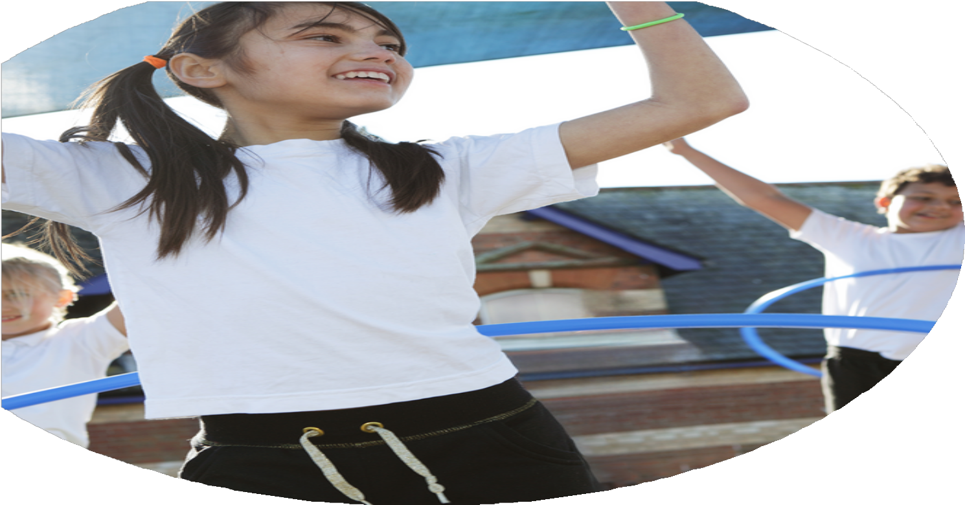
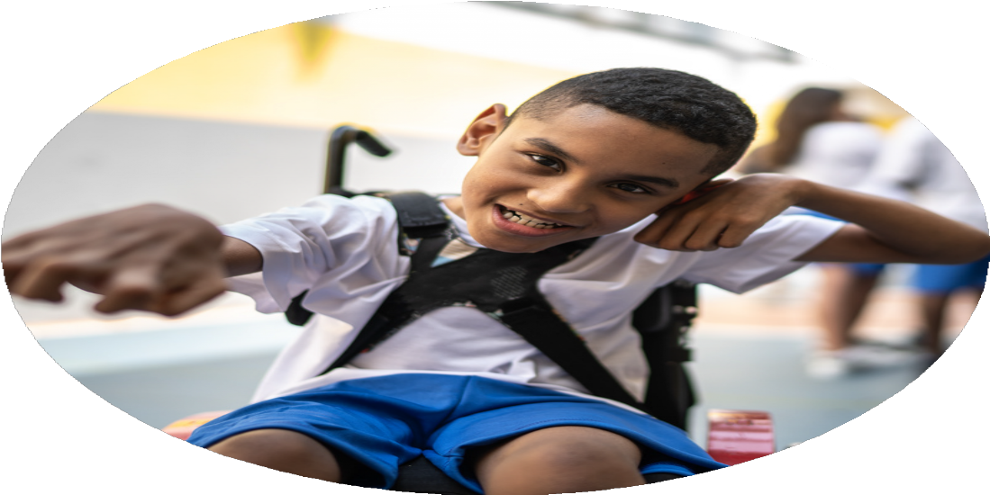
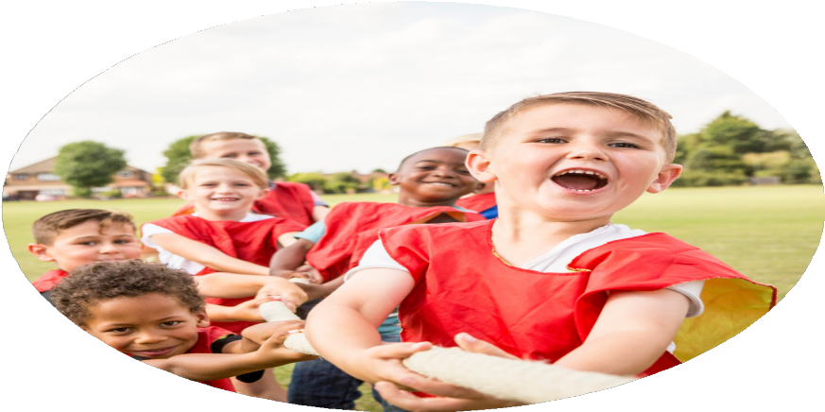



PE Funding

Evaluation Form

Commissioned by

Created by

Images courtesy of Youth Sport Trust
PE Funding Evaluation Form

It is intended that this template should be used as preparation for the completion of the statutory digital reporting tool being introduced this academic year. You can upload data (including swimming) from this template onto this platform once it becomes accessible.
Before you decide how you are going to use the funding for this academic year you should reflect and evaluate the impact of your use of the funding in 2023/24.
All spending of the funding must conform with the terms outlined in the Conditions of Grant document. The template is a working document that you can amend/update during the year.
Based on your evaluation of last year’s funding you should decide what you intend to do this academic year, how you will do it, and what impact you expect it to have.

It is important that the funding is used effectively and based on your school’s needs.
You must use the funding to make additional and sustainable improvements to the PE and sport in your school. You must develop and add to the PESSPA activities that your school already offers.

Summative digital reporting from June 2025 will continue to include swimming and water safety information therefore funding can be used to provide top-up lessons where necessary to ensure pupils meet national curriculum swimming requirements.
Review of last year 2023/ PAGE 24
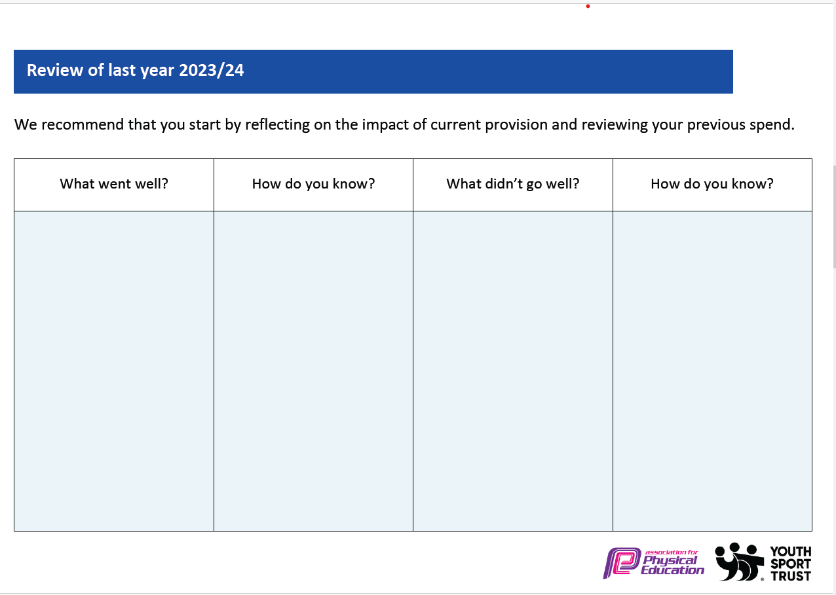
What went well? | How do you know? | Key Priorities | How do you know?
Headlines from 23/24  ● The Sports Mark gold award was successfully renewed to the school in July 2024 for the 2024/25 academic year.  ● Sports coaches from S4YC were employed to deliver sports provision during curriculum time and during lunchtime as well as extra-curriculum sessions. They also provided valuable CPD to teaching staff. Teachers work alongside our coaches- they are not used for cover.  ● The sports coach helps to promote active lunch times through running intra-school competitions such as our Euro themed football tournament. These activities further promote healthy, physical habits to our children giving them opportunities to taste varied sports in either a non-competitive or competitive setting.  ● Specialist coaches are also employed to lead a wide range of after school sports clubs for all children in sports such as fencing, basketball, tennis, Quidditch, rounders and dance.  ● We have created links with outside organisations such as LFC foundation who have offered alternative experiences for our children as well as high quality PE provision and staff CPD.  ● The Specialist School Games Officer provided training and support for our P.E. leader to improve their confidence and competence in leading P.E. and sports.  ● Sports competitions have been reintroduced. A variety of competitive opportunities have been provided for children across key stages.  ● Children have been sign-posted to many of our local clubs where they can extend and develop their knowledge and skills e.g. Football clubs, Dance clubs, Tennis clubs and Gymnastics clubs.  ● All of our extra-curricular clubs are free of charge to parents as they are paid for via the sports premium or are run by school staff at no cost. Our clubs are varied and offer lots of opportunities for children to access sports they may not have ever played for before. Please see below for our 2023/2024 offering.  ● 84% of children accessed our extra-curricular clubs in 23/24.  ● We trained a number our Year 5 and 6 pupils to take on the role of play-leaders and sports leaders. This helped children to partake in active lunch times. |  | ● Increase our extra-curricular offering to aim for 100% of children accessing clubs. Offer a wide variety as well as buying into more expert coaches/facilitators.  ● Continue to provide staff with ongoing CPD. Staff new to year groups, ECTs will be prioritised. Staff audit will also be conducted to find out what areas staff feel they need further support. Staff to continue to work alongside our sports coach.  ● Subject lead to work with specialist consultant to renew our PE long term plan to ensure it offers progression for all and is future proof (staggered mixed classes made it necessary to update).  ● Improve our lunch time offering. The Better Lunchtimes Project will work with our school to audit our current offering and action plan alongside subject lead and headteacher.  ● Improve our SEND provision for dysregulated children through sensory circuits/sensory mats.  ● Equipment audited by PE lead- identified areas for improvement (such as wheel away tennis nets) to ensure all curriculum areas have access to what they need.  ● Improve our cross-curricular links with geography fieldwork skills. OAA site mapping of our school, along with markings and resources. PE and Geography lead to work on events throughout the year with a view to introducing it to our PE curriculum.  ● Enthuse children with a variety of opportunities throughout the year such as rugby tots.  ● PE subject lead to continue to oversee the curriculum, CPD needs of staff, school sports and competitions, active lunchtimes, PE and sports premium and extra-curricular participation. Action plans to be closely monitored and evaluated.

What are your plans for 2024/25?  Intent | How are you going to action and achieve these plans?  Implementation | Costings for each intent/ action
Increased knowledge and confidence of all staff, leading to high-quality curriculum PE lessons. | - Total PE+ Subscription to allow staff access to PE lesson plans and online support.  - S4YC Sports coach (1 full day + extra-curricular club) to allow all staff to receive CPD from a professional in areas of the PE curriculum that they feel less confident in teaching.  - Sports equipment to increase staff confidence by ensuring they have what they need to deliver the curriculum effectively. | £365  £7020  £2341
To improve the PE Curriculum in preparation for the changing needs of our school. | - Edsential Curriculum Design programme | £880
To increase physical activity levels to ensure children are meeting the active 30 minutes within school. | - Extra-curricular clubs delivered each half term. (7 x Afterschool Clubs through Edsential)  - Dave Mcindoe Tennis  - Rugby Tots extra-curricular club x 2  - Better Lunchtimes Project to ensure lunchtimes run as effectively as they can from start to finish and increase children’s activity levels whilst outside. | Edsential Afterschool Clubs  7 x £395 = £2,765  £540  £820  £1118.80
To use physical activity to support mental wellbeing. | - Edsential Rainbow Programme (1 x 6-week programmes delivered to Year 6 children within Spring Term to support management of emotions during SATs) | £1,050
To use school sport to develop social skills and promote physical activity outside of school. | - Access to Wirral School Games competitions and events  - Rugby Tots | Wirral School Games – No cost to access.  £1950
To develop OAA within the PE Curriculum. | - OAA Mapping service through Edsential will create a bespoke map and set of orienteering markers. | £1,000
premium and improve PE curriculum and delivery.

 |  | Total = 18950
Intended actions for 2024/ PAGE 25
Expected impact/sustainability and supporting evidence

Intent / Action | What impact/intended impact/sustainability are you expecting? | How will you know? What evidence do you have or expect to have?
Increased knowledge and confidence of all staff, leading to high-quality curriculum PE lessons.  - Total PE+ Subscription  - S4YC sports coach | Proposed Impact:  - Lesson observations will show pupils receive Quality First Teaching across the whole PE curriculum – supported through our Total PE+ subscription, including making links to wider curriculum and supporting social development.  - Curriculum PE assessments will show an increased number of children working at age-related expectations for PE.  How sustainability will be achieved:  - CPD will have a lasting impact upon teaching and learning.  - Staff will be confident and competent teaching a range of curriculum areas. These in turn can be used to support our school in the future e.g. staff leading extra-curricular clubs.  Proposed impact:  - Teachers will gain a deeper understanding of how to plan and deliver high-quality PE lessons. By receiving hands-on support and training from the professional sports coach, teachers will feel more confident in teaching a broad range of sports and physical activities, ensuring lessons are engaging, inclusive, and challenging for all students.  - Staff will experience a significant increase in their subject knowledge, particularly in areas of PE that may have been less familiar to them. This increased confidence will result in more effective teaching practices, improved lesson delivery, and higher levels of student engagement.  - As teachers become more skilled in delivering PE, the overall physical literacy of students will improve. This means pupils will develop not only basic physical skills but also a better understanding of the importance of regular physical activity for their health and well-being.  - With improved lesson quality, students will be more motivated and excited to participate in PE. This increased enthusiasm should translate into greater participation in physical activities, both in lessons and in extracurricular clubs, leading to better physical fitness, coordination, and overall achievement in PE.  How sustainability will be achieved:  - Teachers will become self-sufficient in their own professional development. As they share their new knowledge with peers, we will see a culture of collaborative learning within the school. This, in turn, will lead to consistent improvements in the PE curriculum and delivery, which will have a lasting impact on the school community.  - The main intended impact is that all teachers will be equipped to deliver high-quality PE lessons, ensuring a consistent and progressive approach to physical education across all year groups. The curriculum will be inclusive, engaging, and aligned with national standards, enabling students to develop a broad range of physical skills.  - Teachers will not only improve their individual skills but will also develop a collaborative culture, where they share ideas, resources, and teaching strategies. This will increase the overall quality of PE across the school and enable staff to continuously support one another in improving their practice. | How will impact be measured:  - Staff Voice across the year will show a growing confidence with the teaching of PE.  - Pupil Voice  - Curriculum PE attainment data.  Improved Staff Confidence:  Staff reported feeling more confident in teaching PE after working alongside the professional coach, particularly in areas where they previously lacked subject expertise (e.g. invasion games, gymnastics).  Effective CPD through Team Teaching:  The coaching model allowed for real-time professional development, with teachers learning new strategies, warm-ups, and skill progressions during lessons.  Sustainable Skill Development:  Teachers are now independently delivering lessons using techniques and approaches modelled by the coach, demonstrating long-term impact beyond the coaching period.  Positive Pupil Outcomes:  Lesson observations showed increased pupil engagement and more effective skill development due to improved teaching quality.  Consistent and High-Quality Delivery:  The coach supported lesson planning and delivery across year groups, leading to greater consistency and a more coherent curriculum experience for pupils.  Increased Use of Assessment:  Staff are now more confident in assessing pupil performance in PE and identifying next steps for progression.  Staff Voice:  Feedback from staff surveys highlighted the value of the coaching support in improving their knowledge, classroom management during PE, and lesson variety.
To improve the PE Curriculum in preparation for the changing needs of our school.  - Edsential Curriculum Design programme | Proposed Impact:  - Our PE Curriculum will be redesigned to allow for the mixed year groups which will form over the next 3 years.  How sustainability will be achieved:  - The curriculum will be in place to allow for progression and reflect the structural changes. This will be in place for future years beyond 26/27. | How will impact be measured:  - Staff Voice will confirm whether the changes have made the teaching of PE more effective.  - Curriculum PE attainment data.
To increase physical activity levels to ensure children are meeting the active 30 minutes within school.  - Extra-curricular clubs delivered each half term. | Proposed Impact:  - More pupils will be meeting their daily physical activity goal (30 minutes within school hours) compared to 2023/24.  - More pupils taking part in PE and Sport Activities outside of school hours compared to 2023/24.  - Increased number of children participating in breakfast and afterschool clubs.  How sustainability will be achieved:  - Children will continue their participation within sports outside of school hours.  - Participation within clubs will contribute to children increasing physical competence. | How will impact be measured:  - Club registers and tracking documents  - Class discussions and pupil voice  - Curriculum PE assessment data (physical skills)
To use physical activity to support mental wellbeing.  - 1 x 6-week Edsential Rainbow Programme | Proposed Impact:  Pupils will report an increase in one or more of the key outcomes of the programmes:  - Resilience  - Self-esteem  - Positive mental wellbeing  How sustainability will be achieved:  - Staff will be using the Rainbow Programmes as CPD to support the emotional wellbeing of children throughout the school day. | Pupil and Teacher voice  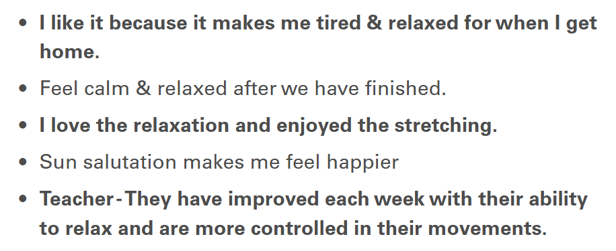  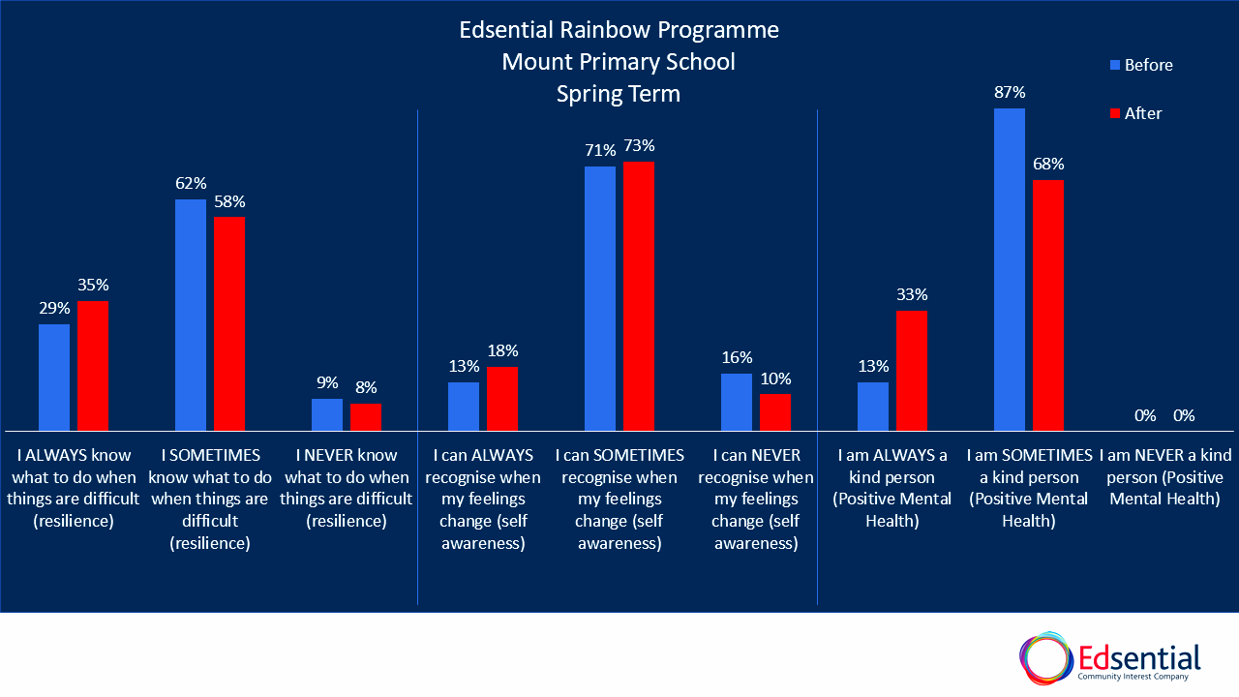  See full report:  https://sway.cloud.microsoft/PfonMFHShqs0KcJ2?ref=email
To use school sport to develop social skills and promote physical activity outside of school.  - Competitions and Events, including Edsential Competitions for All Programme | Proposed Impact:  - Participation within competitive sport will support children to further develop teamwork skills, social and communication skills and supported wellbeing through a sense of ‘togetherness’.  - Increased number of children participating regularly within a sports club/ team as a result of our competitions provision across the year.  - Children will develop a love of a sport and the confidence to strive to achieve their best- leading onto more areas of school and personal life.  How sustainability will be achieved:  - Participation within competitions will lead to an increase in the number of children participating within sports outside of school hours. | How will impact be measured:  - Registers and participation tracking documents.  - Pupil Voice
To develop OAA within the PE Curriculum.  - OAA Mapping service through Edsential | Proposed Impact:  - OAA lessons will have more ‘purpose’ and produce better outcomes with a real life map of the school grounds.  - Wider curriculum lessons will be ‘brought to life’ for children through the use of the school map.  How sustainability will be achieved:  - The map and markers will be used across the coming years. | How will impact be measured:  - Staff Voice  - Pupil Voice
To ensure the children have access to high-quality physical education that promotes lifelong physical activity, health and well-being as well as to maximise the impact of the sports premium and improve PE curriculum and delivery. | Proposed Impact:  - Maximising the Impact of the Sports Premium: To strategically allocate and manage the Sports Premium funding to provide the best opportunities for our pupils. This includes investing in resources, developing staff skills through CPD (Continuing Professional Development), and enhancing extracurricular opportunities, ensuring that the funding has a sustainable and lasting impact.

Actual impact/sustainability and supporting evidence

Intent / Action | What impact/sustainability have you seen? | What evidence do you have?
Increased knowledge and confidence of all staff, leading to high-quality curriculum PE lessons.  - Total PE+ Subscription | Impact:  - Increased Staff Confidence: Teachers have expressed a significant boost in their confidence when delivering PE lessons. With structured and easy-to-follow resources provided by Total PE+, teachers feel more equipped to plan and execute high-quality lessons, ensuring they are consistent and engaging for students.  - Improved Lesson Quality: The use of Total PE+ has led to more dynamic and effective PE lessons. Teachers are now incorporating a wider variety of teaching strategies and activities, aligning with best practices. This has resulted in increased student engagement and participation, and we have observed noticeable improvements in student skills and physical fitness over time.  - Sustainability of Curriculum Development: The ease of access to curriculum resources has ensured that PE planning remains consistent, even in the face of staff changes or absences. This continuity contributes to a more sustainable and long-term approach to delivering high-quality PE.  - Professional Development and Collaboration: The platform has fostered increased collaboration among staff, as teachers can now share resources, ideas, and best practices more effectively.  - Time Efficiency: By utilising ready-made lesson plans and resources from Total PE+, teachers have saved valuable planning time. This has allowed them to focus more on teaching and less on lesson preparation, making the planning process more efficient and sustainable in the long run. | Evidence:  Staff Voice:  - 100% of staff reported an increase in confidence teaching PE through using Total PE+ to support teaching and learning.  Because of the Total PE+ planning, staff reported they now:  Felt more confident delivering high-quality PE lessons  Had better structure and consistency in lesson planning and delivery  Saved time on planning due to ready-made, adaptable resources  Improved pupil engagement through varied and inclusive activities  Observed clearer progression in pupils' skills and understanding  Collaborated more effectively with colleagues using a shared framework  Received more positive feedback from pupils and school leaders  Enhanced their subject knowledge through embedded CPD materials  Delivered more inclusive lessons, meeting the needs of all learners  Used assessment tools more effectively to track pupil progress
To improve the PE Curriculum in preparation for the changing needs of our school.  - Edsential Curriculum Design programme | Impact:  - Curriculum Adaptation to Changing Needs: The Edsential programme has been instrumental in helping us redesign and adapt our PE curriculum to better suit the changing needs of our students as well as the structural changes within classes. By using the flexible framework, we have tailored the content to be more inclusive, engaging, and responsive to the diverse needs of our learners.  - Improved Curriculum Cohesion and Progression: The programme has allowed for a more cohesive curriculum structure across year groups. With a clear progression model in place, students are now building on their skills in a more logical and scaffolded way.  - Increased Teacher Expertise and Confidence: The Edsential Curriculum Design programme has supported professional development, providing staff with the tools and resources to better plan and deliver PE lessons. Teachers are now more confident in their understanding of curriculum design and are able to implement more effective and innovative lesson plans. This has led to increased staff morale and a sense of ownership in the delivery of PE.  - Enhanced Student Engagement and Progress: As a result of the more tailored and engaging curriculum, student engagement in PE lessons has improved. We’ve seen greater participation, enthusiasm, and skill development across the board. Students are now more excited about their PE lessons and are making noticeable progress in both their physical and social development.  - Sustainable Curriculum Development: The Edsential Curriculum Design programme has provided a sustainable framework for ongoing curriculum review and refinement. As the needs of the school continue to evolve, the curriculum can be adjusted and updated with minimal disruption. This long-term adaptability ensures that the PE curriculum remains relevant and effective in the future. | Evidence:  Curriculum Alignment with School Needs:  The PE curriculum has been restructured in collaboration with Edsential to reflect the evolving needs of our school, including a stronger focus on inclusion, physical literacy, and long-term skill development.  Staff Feedback:  Teachers have reported increased confidence and clarity in delivering PE lessons, supported by a more structured and accessible planning scheme (e.g. Total PE+).  Improved Planning and Delivery:  The new scheme ensures consistent lesson progression across year groups and is aligned with national curriculum expectations, reducing planning time and increasing delivery quality.  Pupil Engagement and Progress:  Early observations show higher levels of pupil participation, enthusiasm, and skill development, particularly in previously disengaged groups.  Consistency and Continuity:  The PE curriculum now offers a clearer, whole-school progression pathway from EYFS to Year 6, supporting long-term development in physical education.
To increase physical activity levels to ensure children are meeting the active 30 minutes within school.  - Extra-curricular clubs delivered each half term. | Impact:  - Increased Physical Activity Participation: The extra-curricular clubs have provided students with more opportunities to engage in physical activity outside of the regular PE lessons. As a result, there has been a noticeable increase in the number of students consistently meeting or exceeding the active 30 minutes requirement. Attendance at these clubs has been high, with many students participating in multiple clubs across the year.  - Variety and Engagement: The range of activities offered through the extra-curricular clubs has appealed to a wide variety of interests and abilities. This variety has helped keep students engaged and motivated to stay active, particularly for those who might not traditionally engage in sports.  - Improved Physical and Social Skills: Participation in extra-curricular clubs has helped students develop not only their physical fitness but also social and teamwork skills. By engaging in group activities, students have learned to collaborate, communicate, and support each other, fostering a positive, inclusive environment for physical activity.  - Positive Impact on School Culture: The extra-curricular clubs have contributed to a shift towards a more active school culture.  - Sustainable Long-Term Approach: The investment in professional coaches has provided a sustainable model for delivering high-quality extra-curricular activities. Coaches bring expertise, enthusiasm, and specialised knowledge that enhances the overall experience for students, making the extra-curricular clubs more effective in promoting physical activity. This model can continue to evolve, with different sports or activities introduced each term to maintain interest and engagement. | Evidence:  Extra-Curricular Clubs:  - Total number of clubs ran across the year: 36  - 89% of children across the whole school  - 90% of year 1  - 89% of year 2  - 91% of year 3  - 92% of year 4  - 84% of year 5  - 91% of year 6  Compared to 23/24:  - Total number of clubs ran across the year: 18  - 84% of children across the whole school  - 94% of year 1  - 82% of year 2  - 80% of year 3  - 87% of year 4  - 73% of year 5  - 91% of year 6
To use physical activity to support mental wellbeing.  - Edsential Rainbow Programme | Impact:  - Enhanced Mental Wellbeing: The incorporation of yoga has allowed students to develop important coping strategies for managing stress and emotions. Students have reported feeling more relaxed, focused, and emotionally balanced after yoga sessions. This has been particularly beneficial in helping students manage anxiety or stress in the lead up to SATs.  - Improved Focus and Engagement: Students who participate in the Edsential Rainbow Programme have shown improvements in concentration and attention during lessons. The mindfulness aspects of yoga, including deep breathing and body awareness, have helped students feel more centered and calm, allowing them to engage more effectively.  - Increased Self-Regulation and Emotional Resilience: Yoga has encouraged students to be more aware of their emotions and to develop greater self-regulation skills.  - Fostering a Positive School Environment: The use of yoga to support mental wellbeing has contributed to a more positive and inclusive school atmosphere.  - Positive Feedback from Students and Staff: Both students and staff have shared positive feedback about the programme. Students have expressed enjoyment and appreciation for the yoga sessions, citing feelings of relaxation, calm, and increased self-awareness. Staff have observed the positive impact on students' behavior, focus, and overall wellbeing, further reinforcing the value of this approach. | Evidence:  Rainbow Programme:  - Read our Impact Report here.  https://sway.cloud.microsoft/PfonMFHShqs0KcJ2?ref=email
To use school sport to develop social skills and promote physical activity outside of school.  - Competitions and Events through Wirral School Games. | Impact:  - Development of Social Skills: Participation in Wirral School Games events has provided students with opportunities to develop essential social skills, such as communication, collaboration, and conflict resolution. Through team-based competitions, students have learned how to work effectively with others, share responsibilities, and navigate challenges together, fostering stronger friendships and a sense of community.  - Increased Engagement in Physical Activity Outside School: The competitive environment of the Wirral School Games has motivated students to continue participating in physical activity beyond the school day. Many students have taken their involvement in events as an opportunity to join local sports clubs.  - Promotion of Healthy Competition and Sportsmanship: Students have shown a greater understanding of the values of healthy competition and sportsmanship. They have developed resilience, learned how to handle both success and defeat graciously, and have demonstrated respect for their opponents and teammates alike.  - Improved Teamwork and Leadership Skills: Competing in team sports through the Wirral School Games has helped students develop important leadership and teamwork skills. Students have learned how to take on leadership roles within their teams, motivate others, and contribute to group success.  - Sustainability of Engagement in Sport: The connection with Wirral School Games has provided students with a structured pathway for continued involvement in sport and physical activity. By regularly engaging in competitions and events, students are more likely to sustain their participation in sports over time. T  - Positive Impact on Mental and Emotional Wellbeing: Engaging in school sports and competitions has had a positive impact on students’ mental and emotional wellbeing. | Evidence:  Number of sporting events entered:  - 2024 – 25 - 13  - 2023 – 24 - 8  % of children who took part in a sporting competition or event during 2024-25:  - EYFS – 0  - KS1 –24%  - KS2 –28%  Compared to 2023/24:  - EYFS – 0%  - KS1 18%  - KS2 – 14%
To develop OAA within the PE Curriculum.  - OAA Mapping service through Edsential | Impact:  - Increased Integration of OAA into the Curriculum: The OAA Mapping service has provided us with a structured framework to integrate a wide variety of outdoor and adventurous activities into our PE lessons. This has helped ensure that OAA is not only a discrete part of the curriculum but is also embedded across different year groups, enriching students’ overall PE experience.  - Improved Student Engagement and Enjoyment: Students have shown heightened engagement and enthusiasm for OAA activities. The hands-on, experiential nature of these activities has sparked excitement and provided students with opportunities to challenge themselves in new ways. These activities have contributed to increased motivation and participation in PE, with students eager to take on new challenges in outdoor environments.  - Development of Key Skills: Through the OAA Mapping service, students have been able to develop essential life skills such as teamwork, leadership, problem-solving, communication, and resilience. The outdoor and adventure-based activities have encouraged students to collaborate, support each other, and think critically, fostering a sense of achievement and self-confidence as they overcome physical and mental challenges.  - Increased Knowledge and Expertise Among Staff: The OAA planning has also contributed to increased staff knowledge and confidence in delivering OAA. The resources and guidance provided by Edsential have equipped teachers with the tools to plan and execute high-quality OAA lessons, leading to more effective delivery of these activities. Staff are now better able to ensure the safety and engagement of students during outdoor sessions, further enhancing the quality of the curriculum.  - Sustainability of Outdoor Learning Opportunities: The service has provided a long-term, sustainable model for delivering OAA within the PE curriculum. The activities and resources available through the OAA planning can be easily adapted, ensuring that future cohorts of students will continue to benefit from high-quality outdoor learning opportunities. This long-term sustainability has created a strong foundation for future curriculum development in OAA.  - Positive Impact on Mental and Social Wellbeing: OAA activities have contributed to positive mental and social wellbeing outcomes for students. By taking part in outdoor, challenging experiences, students have had the opportunity to build confidence, improve their emotional resilience, and develop stronger relationships with peers. The sense of accomplishment that comes from completing adventurous tasks has also led to improvements in students' self-esteem and overall mental health. | Evidence:  TR to trial in summer term.  TR to organise staff CPD in 25/26. Develop teacher confidence and skills with a view to introduce it to the curriculum.  TR to work with geography lead to organise school events to help boost teacher knowledge and confidence.

Meeting National Curriculum requirements for swimming and water safety.
Priority should always be given to ensuring that pupils can perform safe self-rescue even if they do not fully meet the first two requirements of the National Curriculum programme of study

Question | Stats: | Further context - Relative to local challenges
What percentage of your current Year 6 cohort can swim competently, confidently and proficiently over a distance of at least 25 metres? | 78%
What percentage of your current Year 6 cohort can use a range of strokes effectively [for example, front crawl, backstroke, and breaststroke]? | 98%
What percentage of your current Year 6 cohort are able to perform safe self-rescue in different water-based situations? | 75%
If your schools swimming data is below national expectation, you can choose to use the Primary PE and sport premium to provide additional top-up sessions for those pupils that did not meet National Curriculum  requirements after the completion of core lessons. Have you done this? | Yes / No
Have you provided CPD to improve the knowledge and confidence of staff to be able to teach swimming and water safety? | No

